**Specific Aims**

Development and application of electromagnetic neurostimulation and recording devices has been growing rapidly over the past decade. Both non-invasive Transcranial Magnetic Stimulation (TMS) and Transcranial Electrical Stimulation (TES) as well as invasive Deep Brain Stimulation (DBS) have become widely adopted to treat neuropsychiatric illnesses. More recently, Intracortical Microstimulation (ICMS) and closed-loop stimulation in which the concurrently recorded neural activity is used to adapt the stimulation protocols have been added. Electromagnetic modeling has become paramount in predicting which neuronal populations will be activated; it is also addressing a need to enhance source localization in electro- and magnetoencephalography (EEG/MEG).

All major open-source brain modeling packages currently available (e.g., SimNIBS, DUNEuro, Brainstorm, SciRun, ROAST) as well as their commercial counterparts (e.g., Sim4Life, Ansys Maxwell, COMSOL) use the electric potential-based Finite Element Method (FEM) for electromagnetic modeling. FEM has been continuously improved over the past 60 years, is simple to implement and can model averaged tissue anisotropy.

At the same time, FEM has two inherent weaknesses specifically affecting high-definition brain modeling. First, it is often impossible even to create volumetric meshes for complicated yet realistic geometries. One example is mesoscale (submillimeter) head modeling with many tightly spaced tissues. Conventional FEM meshes include scalp, skull, cerebrospinal fluid (CSF), gray & white matter, and cerebellum. Another relevant example is large ensembles of tightly spaced cortical neurons/subcortical axons with realistic finite diameters and myelin.

Second, the FEM resolution is always limited by the size of the finite element itself. This leads to severe approximations (some sort of interpolation) when calculating the activating function at the scale of a neuron.

The present proposal aims to develop and disseminate a novel alternative brain modeling engine. In contrast to FEM which uses the electric potential, it operates with the primary (bio)physical quantity – surface (and volumetric) induced electric charge density. To model charge interactions, it naturally employs the modern Fast Multipole Method (FMM) instead of FEM. For piecewise homogeneous biological media of any complexity, only surface charges at boundaries are present. Their interactions are most accurately described by the boundary element method (BEM). This combination of BEM and FMM is the new proposed BEM-FMM charge engine.

The principal advantage of BEM-FMM is a numerically unconstrained spatial field resolution. The method can also solve surface-based models with ${10}^{8}$ facets in 4-8 hours when using a standard multicore computer. An equivalent FEM model would have on the order of ${({10}^{8})}^{3/2}={10}^{12}$ tetrahedra. Such a large FEM mesh could hardly be stored. Therefore, the proposed approach will outperform FEM software by enabling two new solutions:

1. Efficient modeling high-resolution multicompartment brain models at mesoscale, with the expected field/activating function resolution of 10-100 µm. It will become straightforward to model fine implanted objects such as epidural micro stimulation arrays as well as important head compartments such as skin, fat, and muscle of the scalp, cortical+cancellous+cortical skull bones, brain meninges, and brain vasculature.
2. Modeling fields and activating function in ensembles of tightly coupled cellular structures (on the order of ${10}^{4}$ cells given ${\sim 10}^{4}$ facets per cell) in a piecewise homogeneous extracellular space including myelination. The model will account for signals blockade by the finite-diameter arbor and realistic myelination, which has not been possible to date. Hopefully, it will substantially advance the field and lead to new discoveries.

**AIM 1. (years 1-3).** **Improve, complete, and numerically verify the BEM-FMM modeling engine.** Sub-aims: (i) new adaptive mesh refinement algorithm to minimize discretization error; (ii) new algorithm for computing activating function with unconstrained numerical resolution up to a micro/nanometer scale; (iii) new anisotropic volumetric BEM-FMM co-solver; (iv) significant speed up of the FMM engine itself and; (v) full-scale numerical verification against established FEM solvers SimNIBS and DUNEuro at meso(submillimeter) scale.

**AIM 2. (years 1-5).** **Develop and experimentally verify BEM-FMM testbed for enhanced modeling neuromodulation and EEG/MEG with the inclusion of major extra-cerebral compartments.** Sub-aims: (i) method for automated generation of extra-cerebral compartments based on known anatomical MRI data and the existing base segmentations; (ii) algorithm/workflow development including speed up and flexible CAD geometry generators for realistic neurostimulation devices and components; (iii) biophysical evaluation and verification of the modeling pipeline through combined MRI, TMS, TES, EEG, and MEG experiments in 20 heathy subjects and; (iv) delivery of the ready-to-use testbed with all human models and data included.

**AIM 3. (years 1-5) Develop and experimentally verify BEM-FMM testbed for modeling activating function generated by microelectrodes and microcoils in animal axons.** Sub-aims: (i) development of a fast and accurate testbed for computing activating function around implanted neurostimulation devices in a homogeneous anisotropic tissue; (ii) verification for a single giant interneuronal axon of crayfish *Procambarus clarkia* via electrical/magnetic stimulation and; (ii) development of a unique testbed for computing activating function within dense neuronal arbor and verification by compound action potential generation for parallel fibers in turtle *Pseudemys Scripta Elegans* cerebellum via both electrical and magnetic stimulations.

This is a joint study of Worcester Polytechnic Inst. and Martinos Ctr. for Biomed. Imaging, Mass General Hospital.

**Research Strategy**

***Current state of the art.*** Over the past fifteen years, the number of brain stimulation devices to undergo the FDA approval processes has grown exponentially in number and has shown significant sustained interest [1]. Those are targeting Parkinsonian symptoms and tremors [1], presurgical mapping in epileptic patients and motor mapping prior to brain tumor surgery (cf. [2],[3],[4]), as well as brain-computer interfaces (cf. [5]-[10]). Brain stimulation therapies are increasingly used in depression (a fourfold US surge in 2020 [11]). Along with critical applications related to the senior population, depression has been the leading cause of disability in the US among young people ages 15 to 44 ([12],[13], several recent tragic cases at PI’s home institution). 50-60% of people with depression who have failed to receive benefit from medications experience a clinically meaningful response with brain stimulation; one-third of them experience a full remission [13]. For all research and clinical applications, electromagnetic modeling verified by experiment is paramount in predicting which neuronal populations will be activated (neurostimulation) or were activated during different tasks (neuroimaging).

The finite-element method (FEM) is a simple and powerful numerical technique, which is naturally applicable to modeling macroscopically anisotropic biological tissues. For this reason, it has been widely and successfully used to solve various biophysical field problems. For neurostimulation, the leading open-source TES & TMS FEM modeling software is SimNIBS [14],[15],[16]. Another open-source TES FEM simulation package is ROAST [17]. Both packages are not yet capable to model embedded electrodes. On the other hand, an open-source FEM simulation package SciRun [18] is frequently used for the solution of DBS problems with embedded electrodes (cf. [19],[20],[21],[22]). Commercial packages such as Ansys Maxwell FEM software and COMSOL are also widely employed, mostly for the solution with DBS electrodes [23],[24],[25] where the resulting high-resolution fields are then coupled with axonal activation models. Different FEM packages such as SimNIBS and COMSOL may be combined together [26]. A few excellent open-source FEM software packages for EEG (electroencephalography) and MEG (magnetoencephalography) analyses are available, including Brainstorm [27] and FieldTrip [28]. Most recent FEM development resulted in EEG software DUNEuro [29] (see also [30],[31]).

At the same time, FEM is rarely used for the solution of problems with challenging yet biophysically relevant geometries. One example is a microarray embedded into a full-scale MRI-derived head model. Tetrahedral meshing between macroscopic brain tissues and fine microscopic array details alone is a serious problem. Another relevant problem is related to tightly coupled biological compartments such as brain membranes. FEM-based solutions in terms of the electric potential also have difficulties when evaluating an activating function, which is its second derivative. This second derivative does not exist at the boundaries between FEM elements.

**Significance**

This proposal targets the “Mathematical modeling, simulation and analysis” program of NIBIB. It is a joint effort of Worcester Polytechnic Inst. (algorithmic development) and MGH/Martinos Ctr. for Biomed. Imaging (biophysical verification). Its significance could be justified by the fact that the proposed approach will provide either better than FEM solutions or the only solutions for a class of mesoscale/multiscale brain modeling tasks of immediate practical interest. Below, we will present three examples. Comparison of accuracy is given in [32]-[36].

***Example 1. Testing TES fields in the brain for high-resolution anatomical human head model.***A TES stimulation (with a 10-10 electrode configuration) is shown in Fig. 1a. The surface based MIDA model [37] created from T1/T2 MRI images with 0.5 mm isotropic resolution and with 116 anatomical surface meshes is used.

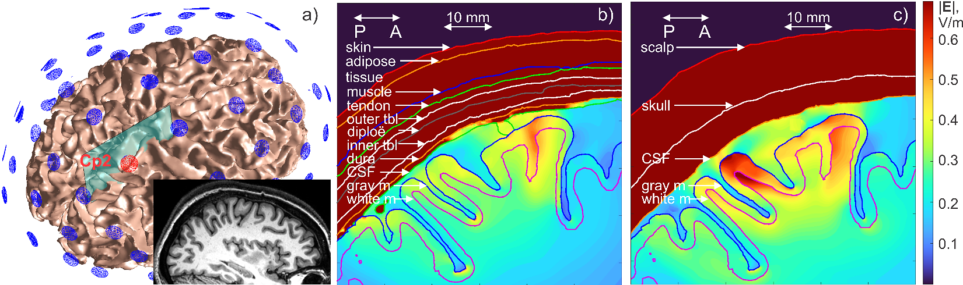

Fig. 1. a) A 10-10 electrode assembly for the MIDA model shown over the white matter surface. The Cp2 electrode (red) is held at 1 V; all other electrodes are grounded (0 V). The inset shows the original T1 data [37]. b) Distribution of the electric field magnitude in the cortex in a sagittal plane shown in Fig. 1a for the complete 0.5 mm resolution MIDA model with all 116 compartments including all anatomical extra-cerebral compartments. c) The same result but for the simplified MIDA model while keeping only the conventional compartments: scalp, skull, CSF, gray matter, and white matter.

The model includes 11 M facets, making it one of the most detailed head models currently available [38]. Literature search indicated that an FEM solution for this full model does not exist due to the model complexity. However, BEM-FMM solves the full MIDA model in ~30-40 min on a multicore computer, when using the high-precision options [39]. This solution agrees well with the voxel-based commercial solver Sim4Life [39].

How is the high anatomical resolution useful for TES? Fig. 1b shows distribution of the electric field magnitude in a sagittal plane from Fig. 1a including all anatomical extra-cerebral compartments with conductivities from IT’IS database [40]. Fig. 1c is the same result but for the simplified MIDA model with only the conventional FEM compartments: scalp, skull, CSF, gray matter, and white matter. The relative error between two solutions in the cortex is 175%! While this error could be smaller in other cases, the situation of Fig. 1 is not atypical.

***Example 2. Activating function on a micrometer scale for DBS electrode within macroscopic head model.***

A multi-compartment head-body model with a fully implanted DBS device (including IPG) and DBS electrodes (Fig. 2a) was constructed based on a realistic device configuration extracted from CT images of a patient at Northwestern University, Chicago IL (Fig. 2b,c). The device trajectory was manually segmented, and a 3D model of the implant was constructed and registered to a heterogeneous human body model consisting of 77 individual head/upper torso compartments. The DBS electrode (Medtronic 3389) is implanted into the thalamus volume. Results for the derivative of the tangential electric field, $dE/dl$, proportional to the activating function of an axon are shown in Fig. 2 for d) homogeneous and e) multicompartment model, respectively [36]. The BEM-FMM solution (blue) is much smoother than the FEM solution (red) due to the unconstrained field resolution. The spikes between neighbor FEM tetrahedra are on the order of 50-100% (note the log scale in Fig. 2d,e); they might change the predicted stimulation intensity by the same amount. This is a well-known FEM issue; large numerical errors in $dE/dl$ have to be mitigated by smoothing and interpolation [41]. Additionally, Ansys FEM solution computes in 1 h 36 min while BEM-FMM solution computes in 2.2 min.

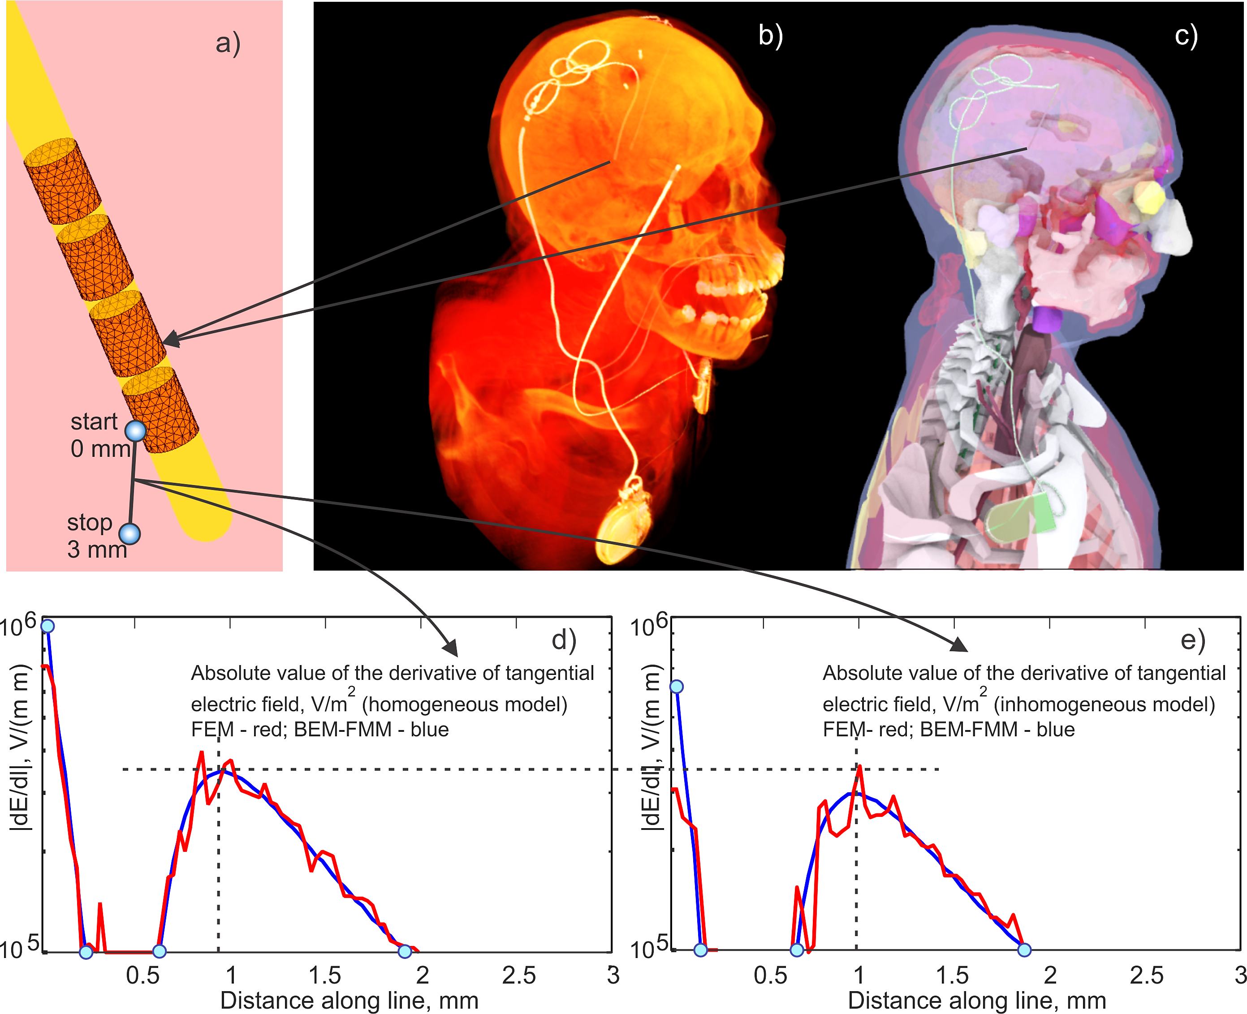

Fig. 2. a) DBS Electrode assembly around insulating urethane lead. Active electrode is assigned—1 V vs IPG (held at zero voltage), and no specific voltage is assigned to other electrodes (floating condition). b) CT of insulating lead/IPG with the electrodes; the second electrode relates to another device. c) IPG Device with the lead and electrodes embedded into the CAD model. d),e) Magnitude of $dE/dl$ (second derivative of electric potential), along a small fraction of the polyline with the length of 3 mm shown in figure a) which starts in the middle of the active electrode held at—1 V for homogeneous d) and inhomogeneous e) head/torso model, respectively. Ansys Maxwell FEM solution is red; BEM-FMM solution is blue.

***Example 3. Fields within a nucleus of physical neurons.*** An excellent work has recently been done on multiscale computing of microscopic transmembrane currents from neuronal columns [42] and, vice versa, on activating single neurons/neuronal columns by TMS [43],[44],[45]. However, in all cases the physical neuronal arbor was assumed not to exist except the one-dimensional cable equation. This means that nearby neurons do not block extracellular potentials from a neighbor, or they do not block external stimulating fields. On the other hand, multiple dendrites/axons/somas and myelin form conductivity interfaces, which accumulate surface charges and thus alter the stimulation fields. BEM-FMM will allow us to start modeling this phenomenon for the first time.

Fig. 3a is a morphological reconstruction of a neocortical pyramidal neuron [46]. The model has 23 axonal branches, 40 basal dendritic branches, 18 apical dendrite branches, and a (spherical, 6.3 µm radius) soma. The number of segments in the model is 9237.The height of neuron is about 900 µm. A high-quality 2-manifold triangular mesh of required radii was created as shown in Fig. 1b; it has 1.4 M triangular facets. The stimulation electric field is generated by two electrodes (40 µm in diameter, 10 µA) separated by 400 µm shown in Fig. 3a. Next, this single neuron was surrounded by 48 clones; a small part of the resulting nucleus is shown in Fig. 3c,d. The clones are randomly located within a small cube centered at the soma of the base neuron to achieve a fixed projected neuron density of 1.6×103 per mm2. Computations are performed under the assumption that the membranes are non-conducting. This condition (end of initial polarization) [47]-[50] allows us to find the local activating function in models of different complexity [51]-[54]. The goal is to compute the external electric field on the surface of the membranes. This field is the stimulation field plus the contribution of all induced surface charges.

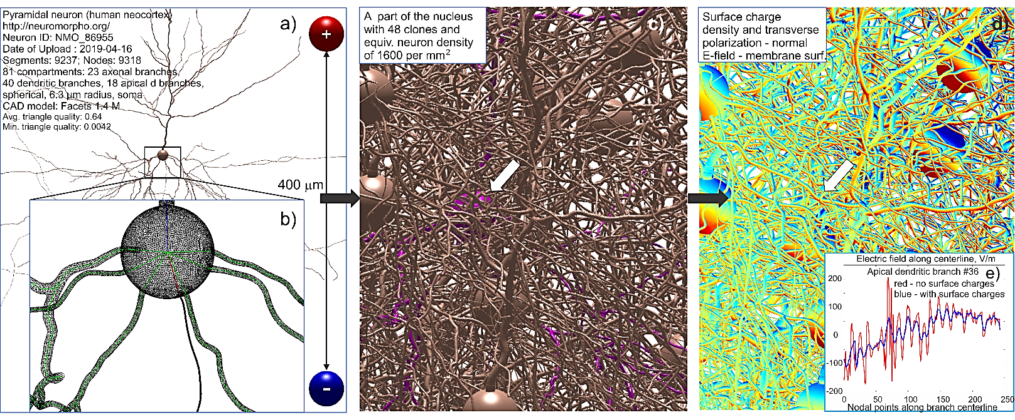

Fig. 3. a) Reconstruction of a single pyramidal neuron and stimulating electrodes. b) Surface mesh model of the membrane. c) Small part of nucleus of 48 clones embedded into conducting gray matter. d) Surface charge density and proportional normal electric field (transverse polarization). Color scale in d) extends from –2 to +2 V/mm. e) – Computed average electric field along dendritic branch #36. Red – without surface charges induced on membrane surface; blue – with surface charges.

FEM cannot solve this problem. It would require approximately ${810}^{17}$ tetrahedra to model the volume enclosing the nucleus if a uniform FEM mesh with the average membrane edge length from Fig. 3b were used. Storage alone of the FEM sparse system matrix would require over a million terabytes of memory, all before even starting the solution. Volumetric meshing the dense neuronal arbor from Fig. 3c is another hardly solvable task. On the other hand, BEM-FMM solves this problem with 67 M facets in 5-10 hours using a 2.1 GHz multicore computer with 256 GB of RAM. The key difference is that one does not need to mesh or solve for the otherwise homogeneous space between the topologically complicated neuronal arbor. The main preliminary result is as follows. Given the neuron density of 1.6×103 per mm2, the effect of neighbors on the base neuron (marked by arrow in Fig. 3) is small. However, the self-effect is large (Fig. 3e). Charges induced on the same dendrite reduce oscillations of the collinear electric field due to geometrical bending: they try to “undo” the bending effect. As a results, the activating function can be altered very significantly. The present example does not consider realistic myelination and intermittent myelin [55]. Further study is planned for a similar problem with myelination (Aim 3).

Despite these (hopefully) convincing examples, the BEM-FMM charge-based approach, as any new development, needs more work. We seek the NIH support to (i) accomplish the efficient mathematical, programming development; (ii) provide all interested users with two world-class modeling testbeds optimized for the best solution of several human neuromodulation and neuroimaging problems and (iii) thoroughly verify the testbeds and their usefulness by a number of experiments and include all experimental models/results into the software.

**Innovation - Programmatic**

The charge-based BEM-FMM was introduced in 2018 with the base concepts given in Refs. [32]-[36]. Its new development suggested in this proposal targets four key steps to assure method’s credibility and usefulness.

***A. Adaptive mesh refinement.*** Adaptive mesh refinement guarantees the minimum discretization error and the most accurate result. It is automated local refinement of a computational mesh in the domains where the field is the largest and the discretization error is the highest. It repeats itself until a convergence criterion (relative field error between two iterations is, for example, less than 0.1%) is met. Adaptive mesh refinement is a chief feature of a high-end commercial Ansys FEM software for most demanding electronics/radiofrequency applications [56]. On the other hand, none of the open-source brain modeling packages implement the adaptive mesh refinement.

The BEM-FMM charge engine is perfectly suited for introducing the adaptive mesh refinement since it deals with the charge density on individual triangular facets (zeroth-order basis functions) only. In the simplest case, a face will be subdivided if its total charge is too large, without worrying about the neighbor facets. This in stark contrast to FEM where a proprietary remeshing algorithm for the entire mesh or its significant part has to be used, which slows down the process. The corresponding algorithm will be described in the Approach section.

***B. New algorithm for computing activating function with unconstrained numerical resolution.*** The neuron activating function is not the electric field itself but a directional derivative of the electric field along the arbor times a constant [47],[48],[49],[50],[51],[53]. The standard first-order FEM outputs the electric potential, which is continuous across the finite element boundaries and a piecewise-constant electric field, which is not. The derivative of the discontinuous function does not exist. Therefore, some averaging approximations are used such as a “super convergent patch recovery technique” [14],[15],[16]. Still, any plots of the activating function within the cortical volume or on an observation surface within this volume are hardly to be found in the modern literature.

We have recently realized that BEM-FMM could compute the activating function directly. The idea is to realize that the tensor gradient of the electric field or its Jacobian, $∇⊗E\left(r\right)$, can be computed columnwise, as the field of a *double layer* of dipoles with the proper dipole orientations [34]. The field of a double layer is the standard FMM task [58],[59]. Therefore, the derivative of the electric field projected onto any direction can be computed by evaluating the field of three dipole layers with the given directions ($\hat{x}, \hat{y}, \hat{z}$) three times. Despite its mathematical simplicity, this step may greatly increase the value of the entire BEM-FMM approach. The corresponding algorithm and preliminary results will be described in the Approach section (Specific Aims 1 and 3).

***C. New anisotropic volumetric BEM-FMM co-solver.*** The published BEM-FMM [32]-[36] was unable to handle macroscopic medium anisotropy. This can now be done by introducing a volumetric mesh in the region of interest, using Schaubert-Wilton-Glisson basis functions known from high-frequency electromagnetics [57] and adding proper volume integral equation [57]. The corresponding algorithm will be described in the Approach section.

***D. Significant speed-up of the FMM engine.*** FMM performance strongly depends on the space partitioning algorithm into a tree. The powerful FMM library [59] originating from its inventors by default uses generic space partitioning applicable to arbitrary volumetric charge distributions. However, for surface charges concentrating at interfaces a significant speed up may be achieved by tailoring space partitioning to a specific surface-based geometry. A joint work with the team of Dr. Greengard [59] is currently underway. Dr. Rachh is helping us to modify the FMM functions and introduce new FMM input parameters in order to semiautomatically tune the partitioning tree to the specific geometry. These parameters will be chosen automatically or adjusted by the user.

**Innovation – Biophysical**

We will attempt to deliver two useful modeling testbeds targeting two practical biophysical problems: (i) more accurate high-resolution TES/EEG modeling and; (ii) high-resolution activating function modeling for realistic electrode/arbor geometries. Both testbeds will contain experimental models and results as an evaluation part.

***A. Testbed for TES/EEG (and TMS/MEG) modeling with extra-cerebral compartments.*** While the extra-cerebral compartments are less important for TMS and MEG due to magnetic field prevalence, their effect on TES and EEG is very substantial (cf. [60],[61],[62],[63],[64] and also Fig. 1). We will introduce and develop a testbed that will either accept user-generated extra cerebral compartments or generate them internally based on the existing standard segmentations (headreco and/or mri2mesh) as well as anatomical rules known from the literature. The corresponding algorithm and preliminary results will be described in the Approach section.

***B. Activating function modeling for realistic electrode/arbor geometries for multiscale applications.*** Models of micro-activation devices (a DBS probe, twisted pair, cone electrode, an ICMS array, a micro-coil) will be simulated with BEM-FMM in a matter of seconds. This in contrast to the widely used commercial software COMSOL that requires tens of minutes for the similar problems and needs to run offline [65]. Simulations will output accurate activating function in homogeneous anisotropic medium suitable for mapping, optimization, and visual inspection. Next, an axonal or cell arbor can be inserted and the extracellular potential and activating function can be recalculated anywhere in space. After that, NEURON software [66] can be used to predict action potential for the given stimulation pulse. The algorithm and preliminary results will be described in the Approach section.

**Approach**

**AIM 1. (years 1-3).** **Improve, complete, and numerically verify the BEM-FMM modeling engine.** This aim targets four programmatic steps of the Innovation section and tests the method. *Preliminary versions* of the BEM-FMM solver for TMS, TES, EEG, and MEG (Windows, Linux, MATLAB platform) have been made available on the Interagency Modeling and Analysis Group (IMAG) of NIH/NIBIB website and GitHub since 2020 [68],[69].

***1.1 Introduction of adaptive mesh refinement algorithm.*** The adaptive mesh refinement algorithm will be the

same for TMS, TES, EEG, and MEG. For the charge formulation, its idea is straightforward. Triangular facets, which have the *largest total* charge are refined i.e., subdivided, for example into four equal sub-triangles using the barycentric triangle subdivision. Thus, in the ultimately refined mesh all facets should carry nearly the *same* total charge, which assures their equal “weight”. This method was used in the past for engineering problems involving capacitance calculations [67] and demonstrated excellent convergence compared to analytical solutions. A variation is being tested that selects the facets with a greatest electric-field contribution to the region of interest. A great advantage of the adaptive mesh refinement is a very significant reduction in the number of BEM-FMM neighbor potential integrals [36] to be precomputed and stored. Those integrals are needed for the tightly spaced shells which are almost in the contact to each other. Equally important is that the user could reduce the numerical discretization error to any desired level. The convergence procedure will be made fast by reusing the previous solution as the starting point for the next one via interpolation.

***1.2 Preliminary work.*** First, the method has been tested for TMS, TES, and EEG using the standard analytical example: the four-layer sphere [70],[71],[72]. Fig. 4 shows the result for a point magnetic dipole as a TMS coil (Fig. 4a). The self-convergence of the adaptive mesh refinement (relative error between two refinement steps in Fig. 4b) strongly correlates with the true relative solution error in Fig. 4c versus the analytical solution [73]. Next, the adaptive mesh refinement has been tested for realistic head models using the same three modalities. Fig. 5 shows the self-convergence of the method for a TMS MRiB91 coil of MagVenture targeting $M_{1HAND}$ of Connectome subject 120111 [95] with the mesh refinement rate of 5%. As expected, the mesh on the *sulcal walls* is mostly refined.

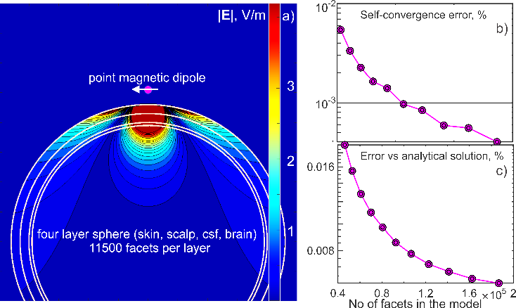

Fig. 4. Result of adaptive mesh refinement for the test case (a four-layer sphere) where the analytical solution is available. Relative self-convergence error (b) tracts true relative solution error versus analytical solution (c).

**1*.3 introduction of new algorithm for computing activating function with unconstrained numerical resolution.*** For computing the tensor gradient of electric field, $∇⊗E\left(r\right)$, the following method outlined in [36] will be applied. The FMM [59] enables computing the field of a double layer of dipoles with arbitrary dipole strengths $υ_{n}$, which are located at $r_{n}$, that is

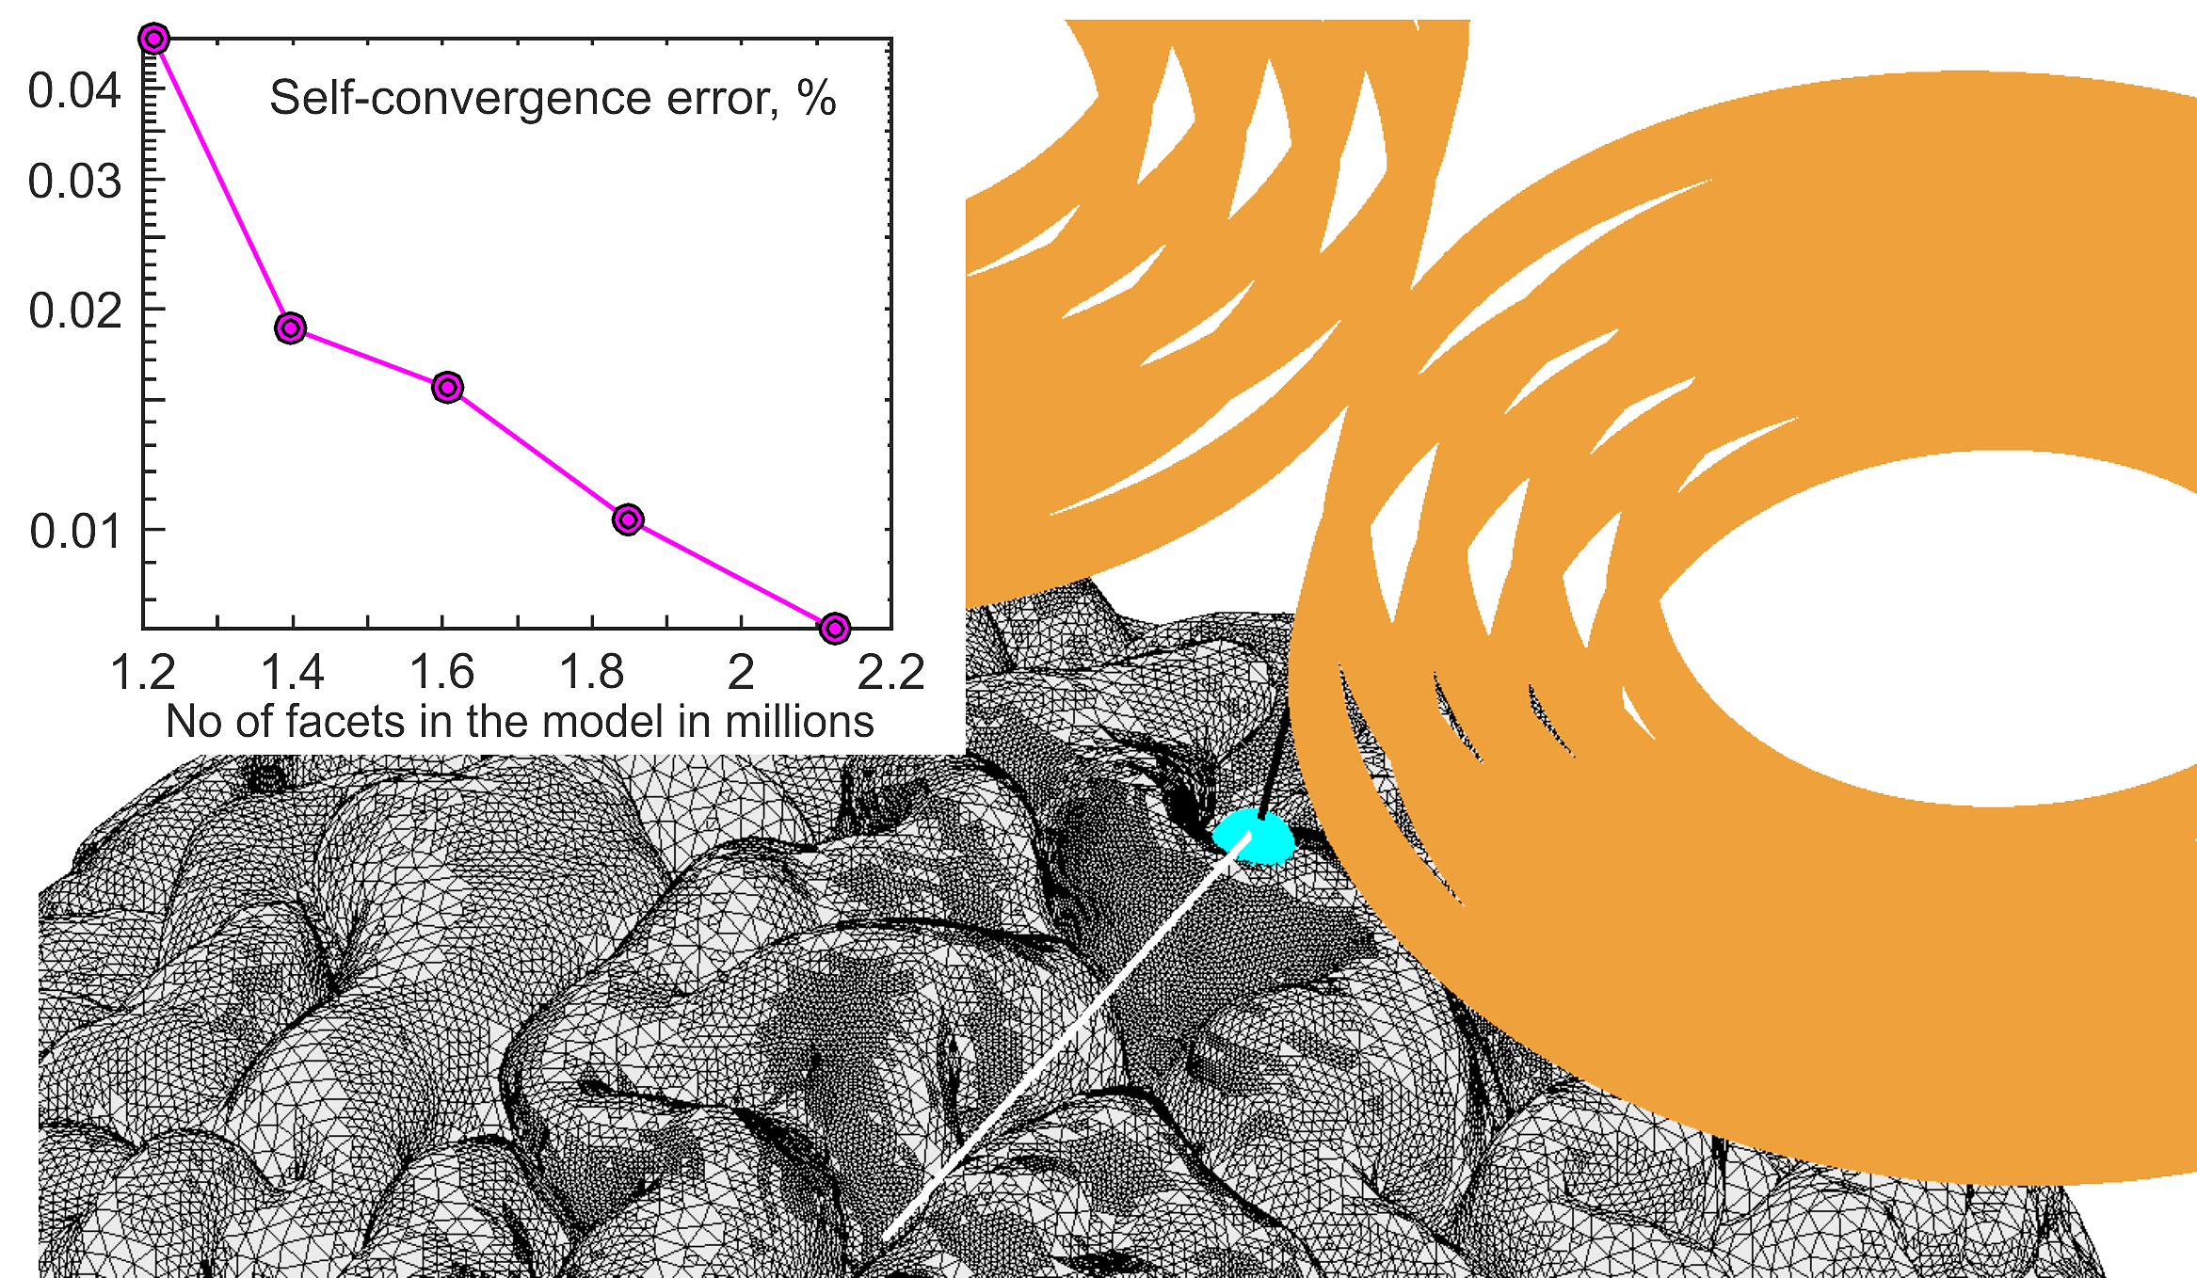

Fig. 5. Result of adaptive mesh refinement for MRiB91 coil of MagVenture targeting the $M_{1HAND}$ area after 5 passes. Method self-convergence (relative) error and final refined mesh of the gray matter are shown.

|  |  |
| --- | --- |
|  | (1) |

By applying this operation three times, we will be able to express each column of the tensor $∇⊗E\left(r\right)$ separately in terms of the previously found surface charge density $c_{n}$. Using the FMM library [59], this will be done in parallel. Once $∇⊗E\left(r\right)$ is known, the field derivative along the any curve, $dE/dl$, is obtained by projection. Expressions for three sets of auxiliary dipole moments have a simple form ( $A_{n}$ is facet area, $ε_{0}$ is dielectric constant of vacuum):

|  |  |  |
| --- | --- | --- |
| $$υ_{n}=\left(\begin{matrix}1 \\ 0 \\ 0\end{matrix}\right)\frac{A_{n}}{4πε_{0}}c_{n} for ∇E_{x}\left(r\right), υ_{n}=\left(\begin{matrix}0 \\ 1 \\ 0\end{matrix}\right)\frac{A_{n}}{4πε_{0}}c_{n} for ∇E_{y}\left(r\right), υ_{n}=\left(\begin{matrix}0 \\ 0 \\ 1\end{matrix}\right)\frac{A_{n}}{4πε_{0}}c_{n} for ∇E_{z}\left(r\right)$$ |  | (2) |

The neighbor potential integrals again require care. Special hypersingular integrals that appear after applying Eq. (1) do not yet have manageable analytical expressions. A joint work with Dr. D. Wilton of U Houston is currently underway to obtain and implement their accurate expressions close to the conductivity interfaces.

***1.4 Preliminary work.*** Today, FEM- or BEM-based $E$-field computations (V/m) are often used to estimate which brain areas are activated by TMS/TES. However, the neuronal activation function is often better described as $dE/dl$. Fig. 6 shows that these two estimates ($E$-field vs. $dE/dl$) could be rather different from each other, even for TMS. BEM-FMM allows us, arguably for the first time, to compute and visualize the activating function derivative $dE/dl$ everywhere in the cortex. The activating function very close to the conductivity interfaces will be computed precisely using analytical integral expressions.

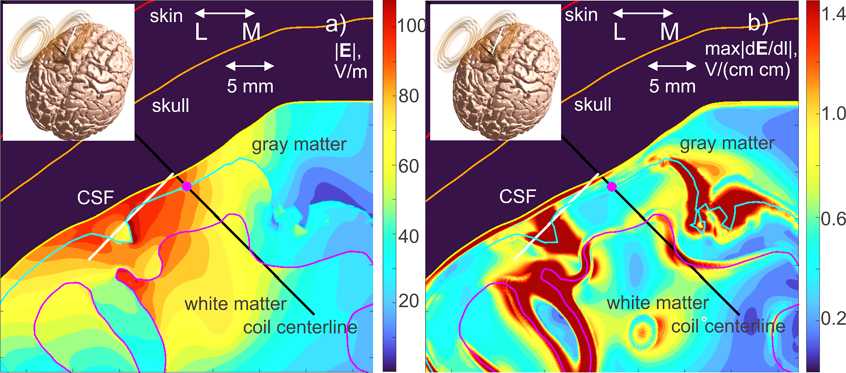

Fig. 6. TMS targeting of $M_{1HAND}$ of Connectome [95] subject #131722 by MRiB91 coil of MagVenture (sagittal plane). a) Electric field magnitude in the cortex. b) 2-norm of $∇⊗E\left(r\right)$ (~maximum value of $dE/dl$ for all possible directions). To our knowledge, this is the first comparative map between the two.

***1.5 New anisotropic volumetric co-solver.*** Our method is based on prior relevant efforts [74],[75], but it is not equivalent to them including a different formulation of the final integral equations. As a result of conductivity anisotropy, a volumetric *dipolar* charge density, $ρ_{υ}\left(r\right)$, will be induced in the tissue. Schaubert-Wilton-Glisson (SWG) basis functions [57] shown in Fig. 7 can support any distribution of volumetric dipoles by assigning a positive charge to one tetrahedron and an equal but negative charge to its adjacent neighbor tetrahedron sharing the same facet $a_{n}$. The corresponding volumetric FMM-accelerated charge equation is written and then coupled to the surface charge BEM-FMM equation.

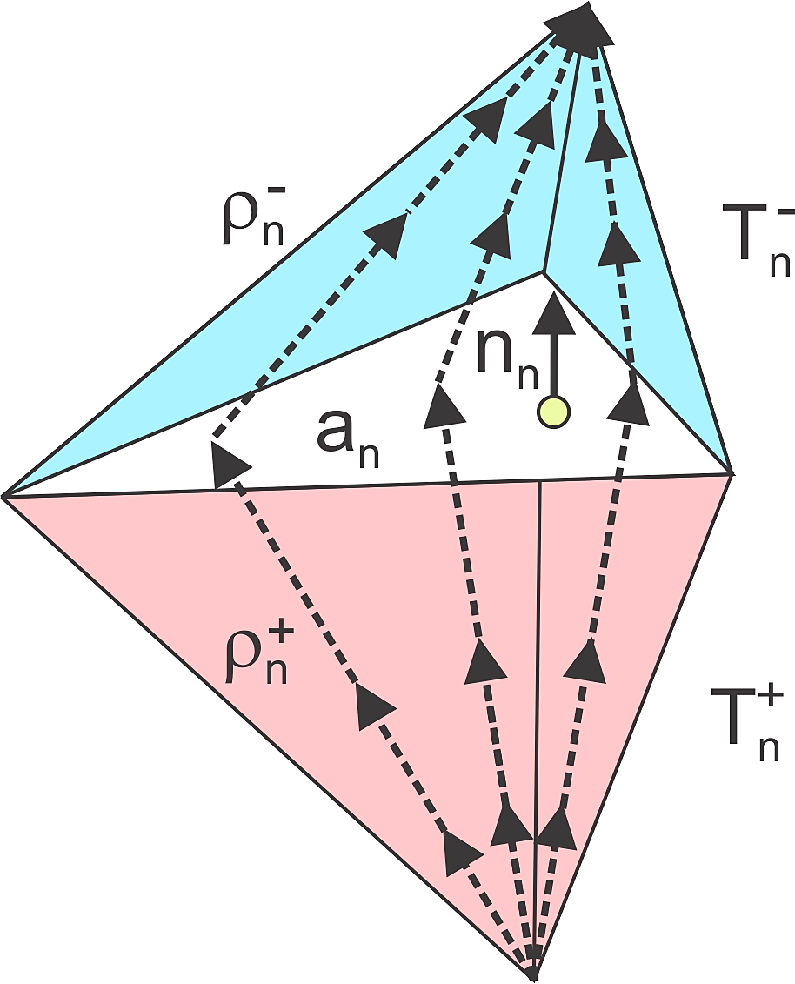

Fig. 7. SWG basis function defined on two adjacent tetrahedra and supporting volumetric dipole density of arbitrary orientation.

***1.6 Preliminary work.*** The method has been implemented and tested against commercial FEM software Ansys Maxwell (Ansys Electronics Desktop 2021 R1) for a base problem shown in Fig. 8. A brick with two surface voltage electrodes (a TES problem) is made composite. An outer shell (‘skull’) has a low isotropic conductivity of 0.01 S/m while the inner brick (‘brain’) has a much higher (variable) anisotropic conductivity. The 2-norm relative error percentage in the vector electric field within the entre volume approaches and falls behind 5% when an 80×80×80 or finer brick subdivision is used. As of now, the method is however somewhat slow since modeling anisotropy is the least developed aspect of BEM-FMM. But it is still faster than Ansys Maxwell FEM (~by the factor of 5). We will therefore also investigate a possibility for direct coupling with a fast first-order FEM, which could be ideal for modeling macroscopic anisotropy.

***1.7 Numerical Verification for TMS/TES, EEG/MEG, and ICMS*.** Independent evaluation by other researchers [90] and our own studies [32],[33],[34],[35],[36] have shown that BEM-FMM is substantially more accurate than the standard first-order FEM on the same computational meshes even without utilizing unconstrained resolution and activating function computations. However, the full-scale numerical verification against established FEM solvers SimNIBS (TMS/TES) [14],[15] and DUNEuro (EEG/MEG) [29] at meso(submillimeter) scale has yet to be performed. It has recently been started in collaboration with two research groups from Germany: Drs. K. Weise and T Knösche (TMS) and Dr. C. Wolters (EEG). TMS and EEG [76] results obtained to date are very promising.

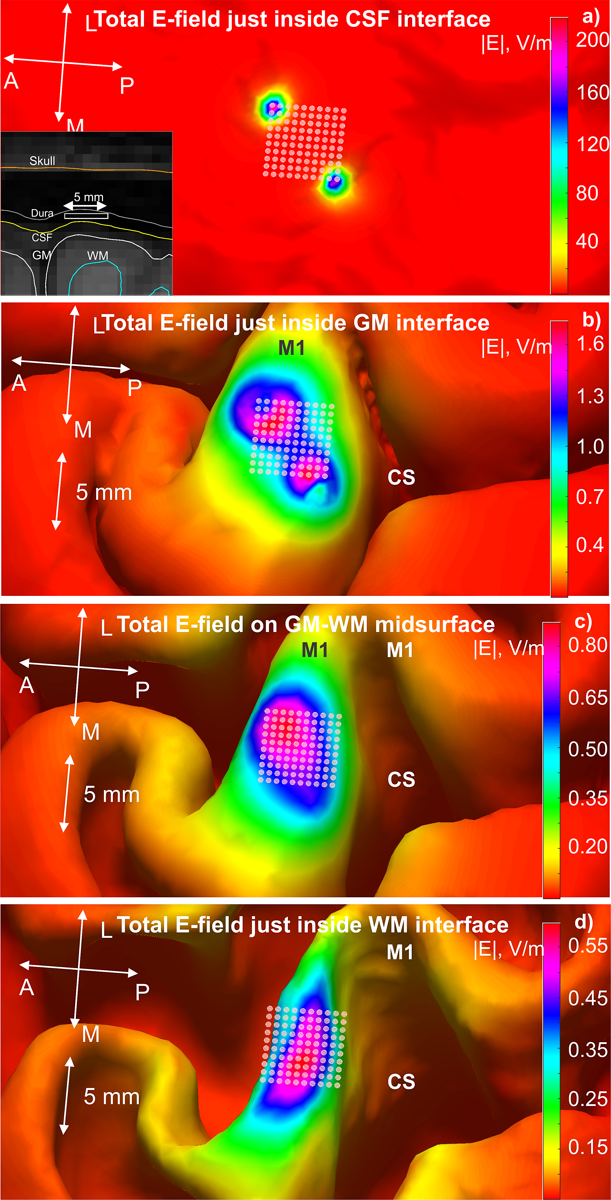

Fig. 9. Epidural ICMS array field into the depth and its deterioration.

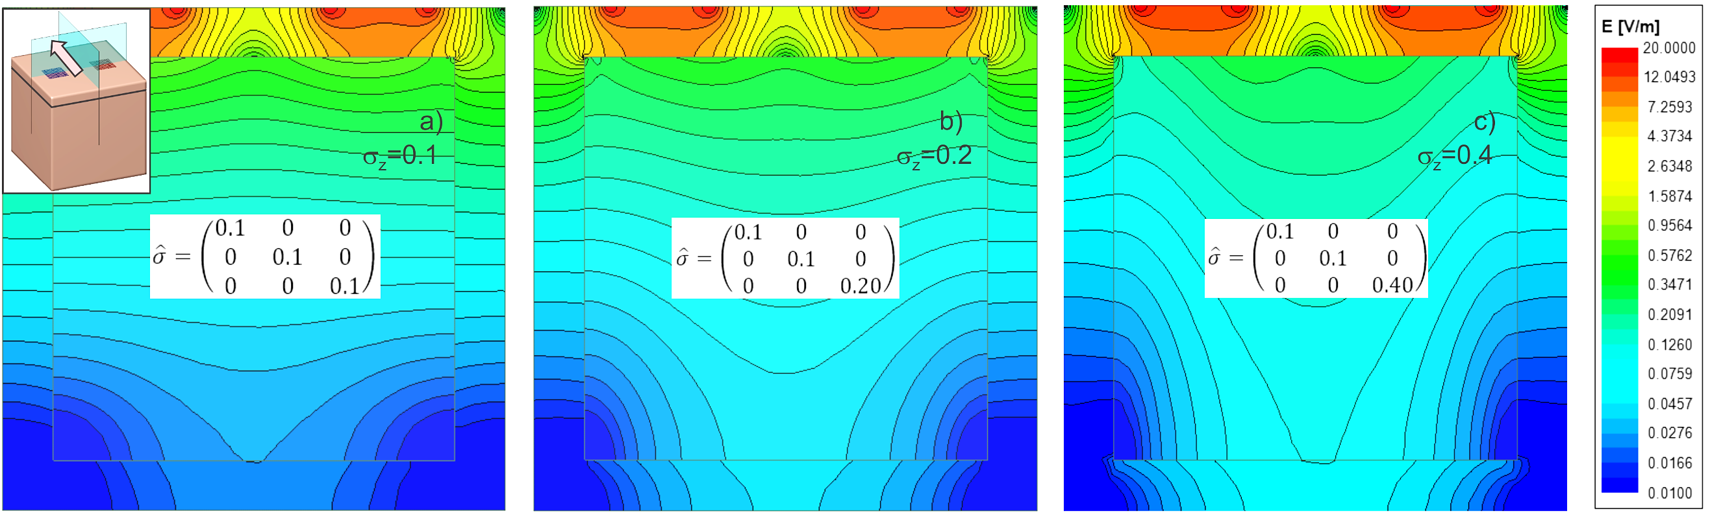

Fig. 8. Volumetric electric field in the composite anisotropic brick.

Since the open-source FEM software for ICMS modeling does not seem to exist per se, we will use there the BEM-FMM self-convergence test with the new adaptive mesh refinement method described above. To demonstrate the capabilities of BEM-FMM, we present in Fig. 9 results for a planar rectangular epidural ICMS array (5×5×0.5 mm) with 100 circular electrodes (each with radius of 167 μm) embedded into the full head model of a 27 year old healthy female above the ${M1}_{HAND}$ area of the left hemisphere ([36], Max Planck Inst.) Two furthest diagonal electrodes are assigned ±1V; all other electrodes are grounded. This example effectively performs true multiscale modeling and shows that the array focality and field strength quickly deteriorate when approaching the cortical volume.

***1.8. Improving method speed.*** While BEM-FMM should perform faster than FEM at mesoscale and multiscale due to better scaling with increasing mesh size/resolution, its present speed at 1 mm resolution approaches the speed of the first-order fastest FEM (SimNIBS) but does not exceed it [77]. Speed improvement heavily relies on the performance of the FMM library [59] itself and it is crucial. In order to increase the speed, we suggest tailoring the generic FMM library [59] specifically for brain modeling by correcting the space partitioning tree as described in the Innovation section. Another promising approach to be tested are modern block Krylov solvers [78] which will allow BEM-FMM solutions with multiple right-hand sides.

***1.9. Deliverable (year 3).*** The deliverable of this aim will be a faster (by a factor of 3-4) BEM-FMM solver with automated adaptive mesh refinement and accurate field/activating function outputs, applicable to head modeling with an arbitrary combination of isotropic and macroscopically anisotropic intra- and extra-cerebral compartments. The solver will be applicable to TMS/EEG/ICMS as well as to EEG/MEG since the underlying charge engine is the same. Differences are in source construction and in extra modeling for voltage electrodes [36].

**Aim 2. (Computational part) Develop BEM-FMM testbed for enhanced modeling of neuromodulation and EEG/MEG neuroimaging with the inclusion of major extra-cerebral head compartments.** The present testbed will be applicable to both neurostimulation (TMS, TES, ICMS) and neurophysiological recording tasks.

***2.1 Value of (finer) extra-cerebral head compartments.*** Conventional FEM head meshes today are obtained from the segmentation of T1/T2 MRI images with 0.7-1 mm isotropic resolution. Two widely used open-source segmentation pipelines are mri2mesh (based on FreeSurfer [79],[80] and FSL [81]) and headreco (based on SPM/CAT [82]). The major segmented components are scalp, skull, cerebrospinal fluid (CSF), gray & white matter, and cerebellum tissues. Eyes and air might be added. Segmenting finer extra-cerebral structures (constituents of the scalp, skull, brain meninges, as well as blood vessels) from MRI scans is more difficult and has received less attention to date [83]. It can be performed manually [62]. A newly developed charm pipeline [83] will additionally segment cortical and cancellous bones but its accuracy and applicability still remain unclear.

On the other hand, multiple studies (e.g., [60],[61],[62],[63]) including our own research [64] have confirmed that the effect of those extra-cerebral compartments on TES and EEG (and to a lesser extent on TMS and EMG) modeling predictions in the cerebral cortex can be very significant. The 2-norm and RDM field errors may easily exceed 100% when the extra-cerebral tissues are omitted or improperly averaged. Different averaging approaches (cf. [60],[61],[62],[63],[64]) do exist and work reasonably well. And yet, having an accurate isotropic multi-compartment assembly with the proper tissue properties can be considered as a reference or ground truth [60],[61]. To create this assembly, we propose to use anatomical rules known from the literature and add to the existing segmentations the following isotropic compartments: skin, fat, and muscle of the scalp, outer table, diploë, and inner table of the skull, as well as three brain meninges: dura mater, arachnoid, and pia mater.

***2.2 Why BEM-FMM?*** BEM-FMM will be ideal for modeling this kind of problem. Not only can it treat multi-shell models with 2-4 M surface facets better and faster than standard first-order FEM (cf. [90],[64]), but it can also naturally resolve the effect of tightly spaced shells such as meninges, and also resolve a fine structure of brain lesions. For the same problems, FEM would need prohibitively large meshes (estimated 30-60 M tetrahedra due to very small tetrahedra sizes in certain regions). A detailed verfication plan and preliminary results will follow.

***2.3 How to generate extra-cerebral head compartments?*** It is expected that higher MRI resolution and better imaging protocols will eventually lead to individual segmentation for extra-cerebral compartments. Three examples of enhanced-resolution models: 0.5 mm [91], 0.25 mm [92], and 0.76 mm (dMRI/T1/T2) [93] can be mentioned. The submillimeter vasculature resolution is discussed in [94]. All Human Connectome Project [95] models are 0.7 mm T1/T2 images. However, the automated segmentation of those compartments is not yet available.

As a first option, the suggested BEM-FMM testbed will therefore accept user-generated extra cerebral data based on some segmentation (e.g., manual [62] or by virtue of deep learning [96]). If user’s data are not available, it will generate extra-cerebral data *automatically*, based on the standard segmentation (e.g., headreco) and anatomical rules known from the literature. This generation will be done in seconds and the entire model will be solved in a few minutes. Below, one such scheme is outlined that will create manifold meshes.

***2.4 Generation of extra compartments based on existing standard segmentation and anatomical rules.***

*Scalp→skin, fat, muscle.* To partition space between existing individual skin and bone shells, the following relative thicknesses will be used: skin – 20%, fat – 40%, muscle – 40%. These values are widely employed in human head model constriction in safety studies for the MRI radiofrequency coils (cf. [84] and other sources cited there).Other references (e.g., [63]) will be used to predict the relevant low-frequency conductivity values.

*Skull→outer table, diploë, inner table.* Most important for neural stimulation and imaging are the frontal and parietal lobes. Based on the results reviewed in Refs. [85],[86],[87],[88],[89] for approximately 300 subjects combined, the following average relative estimates can be deduced for the volumetric skull topology in the frontal lobe: outer table (cortical bone) – 30%; diploë (cancellous bone) – 40%, inner table (cortical bone) – 30%. For the parietal lobe, the relative diploë thickness is significantly higher; it may easily exceed 50% (cf. Ref. [89]). The following average relative values will be used there: outer table (cortical) – 30%; diploë (cancellous) – 50%, inner table (cortical) – 20%. A smooth transition is automatically made from one lobe to another when moving in the anterior-posterior direction and passing through the vertex of the skull. Variations of this scheme are easily programmable. According to Refs. [60],[61], the isotropic multi-compartment skull assembly that accounts for spongy and compact portions of the skull separately can be considered as a reference or ground truth. The following conductivity values can be used [61]: cortical bone: 0.0064 S/m, cancellous bone: 0.029 S/m.

*CSF→dura mater, arachnoid mater, true CSF, pia mater*. Here, we will use integral data given in Ref. [62] for the meningeal layer (dura, arachnoid, pia) thicknesses, which were estimated from literature [97],[98],[99],[100] by noting that references are varied due to the heterogeneous geometry of the layers themselves. The suggested averaged thickness data are 1.11 mm for dura, 0.2 mm for arachnoid, and 0.1 mm for pia mater [62]. All three meninges of the cortex fold and descend deep down into the longitudinal fissure. Therefore, the dura mater in between the two hemispheres (*falx cerebri*) will be made proportionally thicker.

***2.5 Preliminary results****.* The scheme described above has been implemented using constrained mesh deformations and then tested for 16 Connectome subjects [95] with the isotropic resolution of 0.7mm. First, both headreco and mri2mesh segmentations have been applied following Ref. [101]. Visual examination has indicated a reasonable agreement in the placement of extra-cerebral compartments in either case. Fig. 10 shows the standard (a,b,c,d, headreco) and enhanced (e, f) segmentations for Connectome subject 120111 overlapped with T1/T2 NIfTI images, respectively, in a sagittal plane which is passing through the premotor, primary motor, and somatosensory cortexes. Skin, three compartments of the skull, and dura mater agree well with the background MRI information. The reason for the good agreement is likely the fact that the extra-cerebral components are created exactly following the *already existing* individual base segmentation.

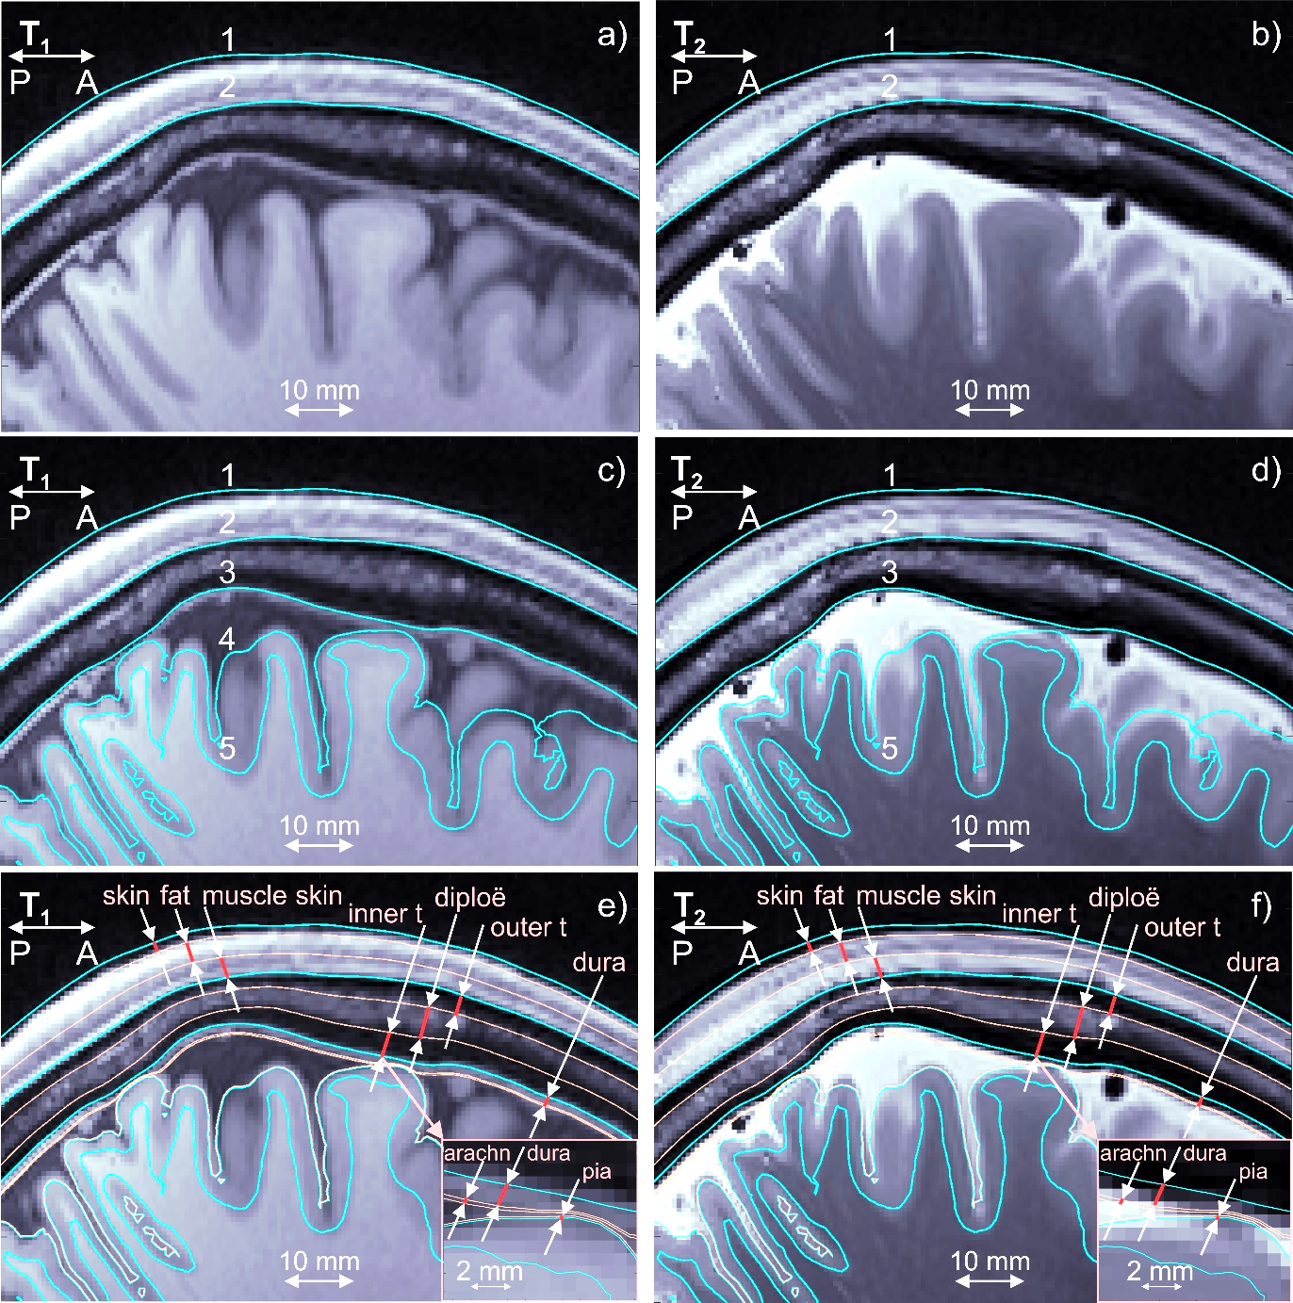

Fig. 10. a,b) T1 and T2 NIfTI images for Connectome subject 120111 and the base headreco segmentation for scalp (1) and skull (2) shown in blue in sagittal plane. Cancellous bone is seen on both T1 and T2 images. Dura mater is seen on T1 image. c,d) The same images and base headreco segmentation for scalp (1), skull (2), CSF (3), gray matter (4), and white matter (5) in blue. Automated headreco routine adds dura to the CSF volume which may create a large modeling mistake [62]. e,f) – Base headreco segmentation (blue) and new extra-cellular compartments (pale pink). They agree well with the background MRI information. Two insets in right bottom corners display fine meninges: dura, arachnoid, and pia. The last one is 0.1 mm thick.

The effect of so constructed extra-cerebral compartments on TMS and TES has been investigated next. For TMS, which is known to be much less sensitive to extra-cerebral topology variations due to the tangential nature of the electric field, their effect appears to be moderate as seen in Fig. 11a,b. Fig. 11a,b shows the total electric field in a sagittal plane of Fig. 10 for the base and enhanced segmentation modes, respectively. TMS CoolB35 coil of MagVenture targets the $M_{1HAND}$ area. Numerical field resolution is 75 µm. The RDM (shape) error between the two sets of data within the gray matter volume is 25%. However, TES targeting of the same $M_{1HAND}$ area with the ring electrodes [121] shown in Fig. 11c,d is different. The RDM error in Fig. 11c,d approaches 95% (similar to Fig. 1!). The base segmentation in Fig. 11c predicts a strong intracortical maximum at the sulcal wall of the precentral gyrus while the enhanced segmentation does not. Also, a stronger field is predicted at the crown of the postcentral gyrus.

**Aim 2. (Verification part) Experimentally evaluate BEM-FMM testbed for enhanced modeling of neuromodulation & EEG/MEG neuroimaging via median nerve stimulation and TES modulated TMS mapping.**

***2.6 Experimental Evaluation.*** The principal experimental evaluation will include several steps. All generated results – MRI data, segmentations, high-density EEG/MEG measurements, TMS/TES targeting data, and navigation – will be publicly disseminated along with the testbed including the modification and redistribution rights.

***2.7 MRI data acquisition, base and enhanced model construction.*** We will recruit 20 healthy right-handed [103]volunteers (10 male, 10 female) adults without contraindications for EEG, MEG, and TMS [104],[105]. Informed consent will be obtained from all participants prior to the study. The study will be approved by the IRB at Massachusetts General Hospital (MGH). MRI data will be obtained using a 3T Siemens Prisma scanner. T1 images will be acquired with a Multi-Echo Magnetization-Prepared Rapid Acquisition Gradient Echo (ME-MPRAGE) sequence [106] and the T2 data will acquired with a T2-SPACE sequence [107], both at 0.7 mm resolution. Next, we will use the SimNIBS segmentation pipeline[102] to construct base computational models. We have constructed multiple such models in the past [108]. Finally, the enhanced models will be created including the extra-cerebral compartments.

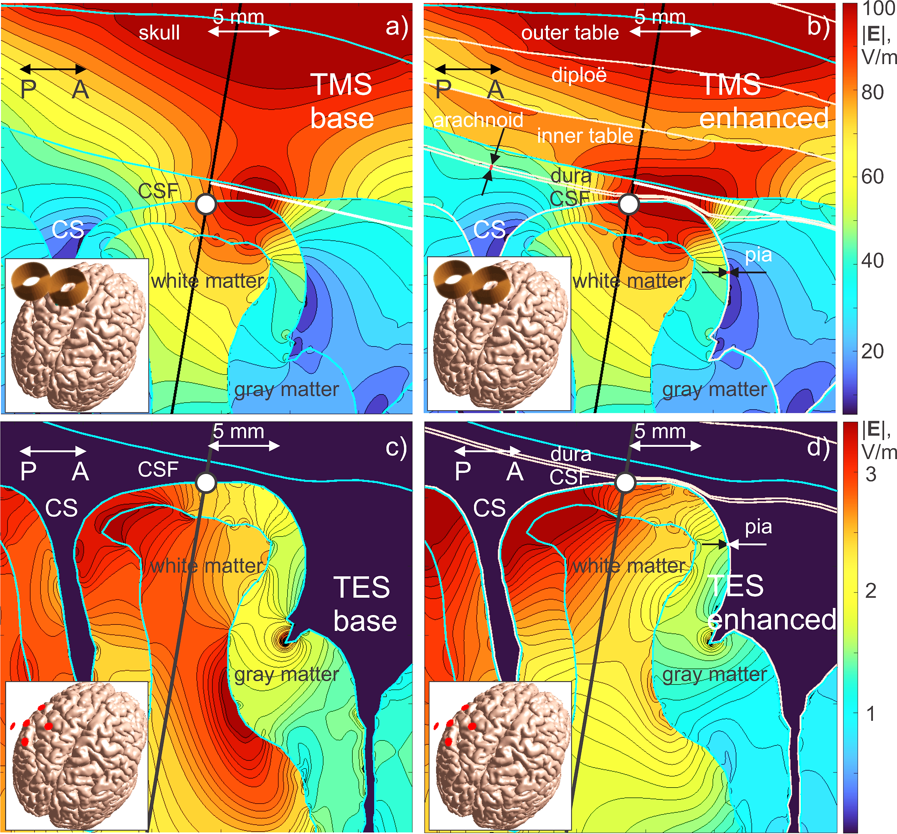

Fig. 11. Total electric field in a 30×30 mm window of sagittal plane generated by TMS (a,b) or TES (c,d). For TES, large extra-cerebral fields are not plotted. Both TMS (CoolB35 coil of MagVenture at 9.4e7 A/m) and TES (ring electrode configuration at ±10 V are targeting $M_{1HAND}$ area of the left hemisphere (on insets). Target point is a white circle, coil axis (center electrode axis) is a black line. a, c) – Results for the base headreco segmentation. b, d) – Results for the base segmentation with 9 extra-cerebral compartments. Numerical resolution is 75 µm. Execution time in b) is 180 sec, in c) is 300 sec for 2.4 GHz CPUs.

***2.8. Experiment A: EEG/MEG Measurements and hypotheses.*** *Median nerve stimulation and data collection.* Electrical stimuli over the median nerve at the right wrist will be delivered using brief transcutaneous pulses every 1.5 seconds. The task is to respond to each stimulation pulse by pushing a button with the left-hand index finger. This generates MEG and EEG evoked responses in $S_{1HAND}$ (primary somatosensory cortex contralateral to the nerve stimuli), and $M_{1HAND}$ (primary motor cortex contralateral to the motor response) at different latencies [109],[110]. The responses will be measured at the Martinos Center using a 306-channel MEG system and 128 MEG-compatible EEG channels (Elekta Neuromag, Helsinki, Finland). For source localization, we will compare two different BEM-FMM models – the base and the enhanced one – with each one. BEM-FMM provides a unique “free” opportunity to obtain a high-density source localization with a numerically unlimited number of cortical dipoles [35] via the Helmholtz reciprocity principle [113],[114]. We will control BEM-FMM source localization results with the established MEG/EEG software suite MNE [111],[112].

*Hypothesis #1: Better consistency of MEG than EEG results between base and enhanced models.* Since MEG (like TMS) is less affected by extra-cerebral compartments (magnetic field is weakly affected by conductivity interfaces), localization results for the base and enhanced models should be similar. Since EEG (like TES) is strongly affected by extra-cerebral compartments (electric field is strongly affected by conductivity interfaces), the localization results for both models should be different. Outcome: statistical consistency data for 20 subjects.

*Hypothesis #2: Better correlation between EEG and MEG localizations for the enhanced model.* Assuming that the MEG data are ground truth, the EEG source localization on the enhanced model must better agree with the MEG data than the EEG source localization on the base model. Outcome: correlation data for 20 subjects.

***2.9. Experiment B: TMS/TES Measurements and hypothesis.*** It has been shown multiple times that a cathodic tDCS (transcranial direct current stimulation) applied to the motor area for ~10 min increases the motor threshold and decreases the size of TMS motor evoked potentials (MEPs) for hand muscles [115]. *Hypothesis #3: The enhanced head models will enable better tDCS targeting and thus enable smaller tDCS currents to achieve the same effect.* Outcome: comparison of MEP amplitudes to suprathreshold TMS (120% resting motor threshold) for equal current levels but for different electrode placement predicted by the base and enhanced models.

*TMS map of first dorsal interosseous (FDI) muscle representation.* The FDI muscle of the hand can be mapped with high tolerability (cf. [116],[117],[118]). Fig. 12a shows the approximate cortical area of the FDI muscle (thumb) within $M_{1HAND}$ vs abductor digiti minimi (ADM) muscle (little finger) [116],[117]. The TMS mapping will start with putting the coil at the anticipated center of the hand knob. The FDI hot spot will be approximately determined first, by increasing intensity to see a clear suprathreshold MEP. Next, scanning through the map of Fig. 12b will be performed while recording FDI MEPs for every target point with the constraints of 4 stimuli per site, a 5 sec interstimulus interval to avoid inhibitory effects, and an approximately 20 ms long latency onset of the MEP. The EMG data will be recorded with a TMS-compatible amplifier (BrainProducts ExG MR) using the bipolar electrode setup (Fig. 12c). This step will be performed with the fully automated robotic TMS positioning system [119] available (starting with 2022) in the TMS Core laboratory of the Martinos Center. We will cover a cortical area of 4×4 cm projected to the skin surface, with 12×12 =144 mapping points (step size of 3.33 mm).

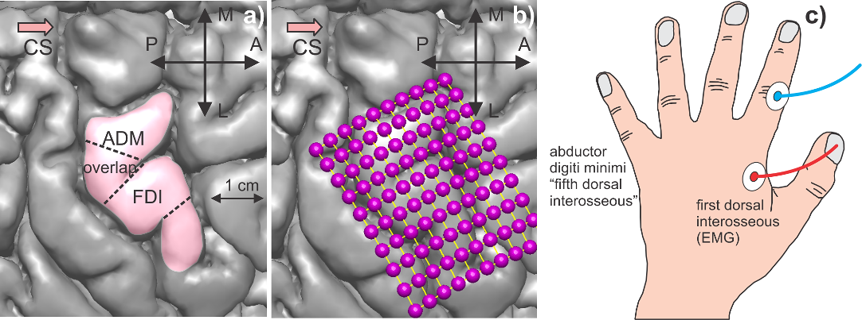

Fig. 12. a) Approximate position of FDI muscle representation within the hand knob [120] of the precentral gyrus [116],[117]. b) Target points of exhaustive motor map. c) Recording EMG setup with ref. electrode placed on the skin overlying interphalangeal joint of the index finger.

*Targeting center of gravity of the TMS FDI map with ring electrode tDCS.* A Starstim tDCS-EEG system of Neuroelectrics, Barcelona, Spain, available (starting with 2022) in the TMS Core laboratory will be used to target the center of gravity of the TMS FDI map. It will be operated in a ring electrode configuration [121] which enables better TES targeting and with a cathodal direct current delivered at 1-1.5 mA for ~10 min [115]. The best cathode positions will be determined separately for the base head model and the enhanced model, respectively. Statistically significant deviations in the tDCS stimulation currents are expected within the pool of 20 subjects. The after-effect of TES on suprathreshold TMS MEPs (120% of resting motor thresh.) will be finally measured for both cathode positions.

***2.10 Preliminary experimental results and testbed evaluation.*** Fig. 13 shows our preliminary EEG/MEG data from one healthy subject. Dr. Raij (Co-Investigator) collected a 1 mm T1 MRI scan followed by somatosensory evoked responses during simultaneous MEG+EEG (306+70 channels) recordings of experiment of Section 2.8.

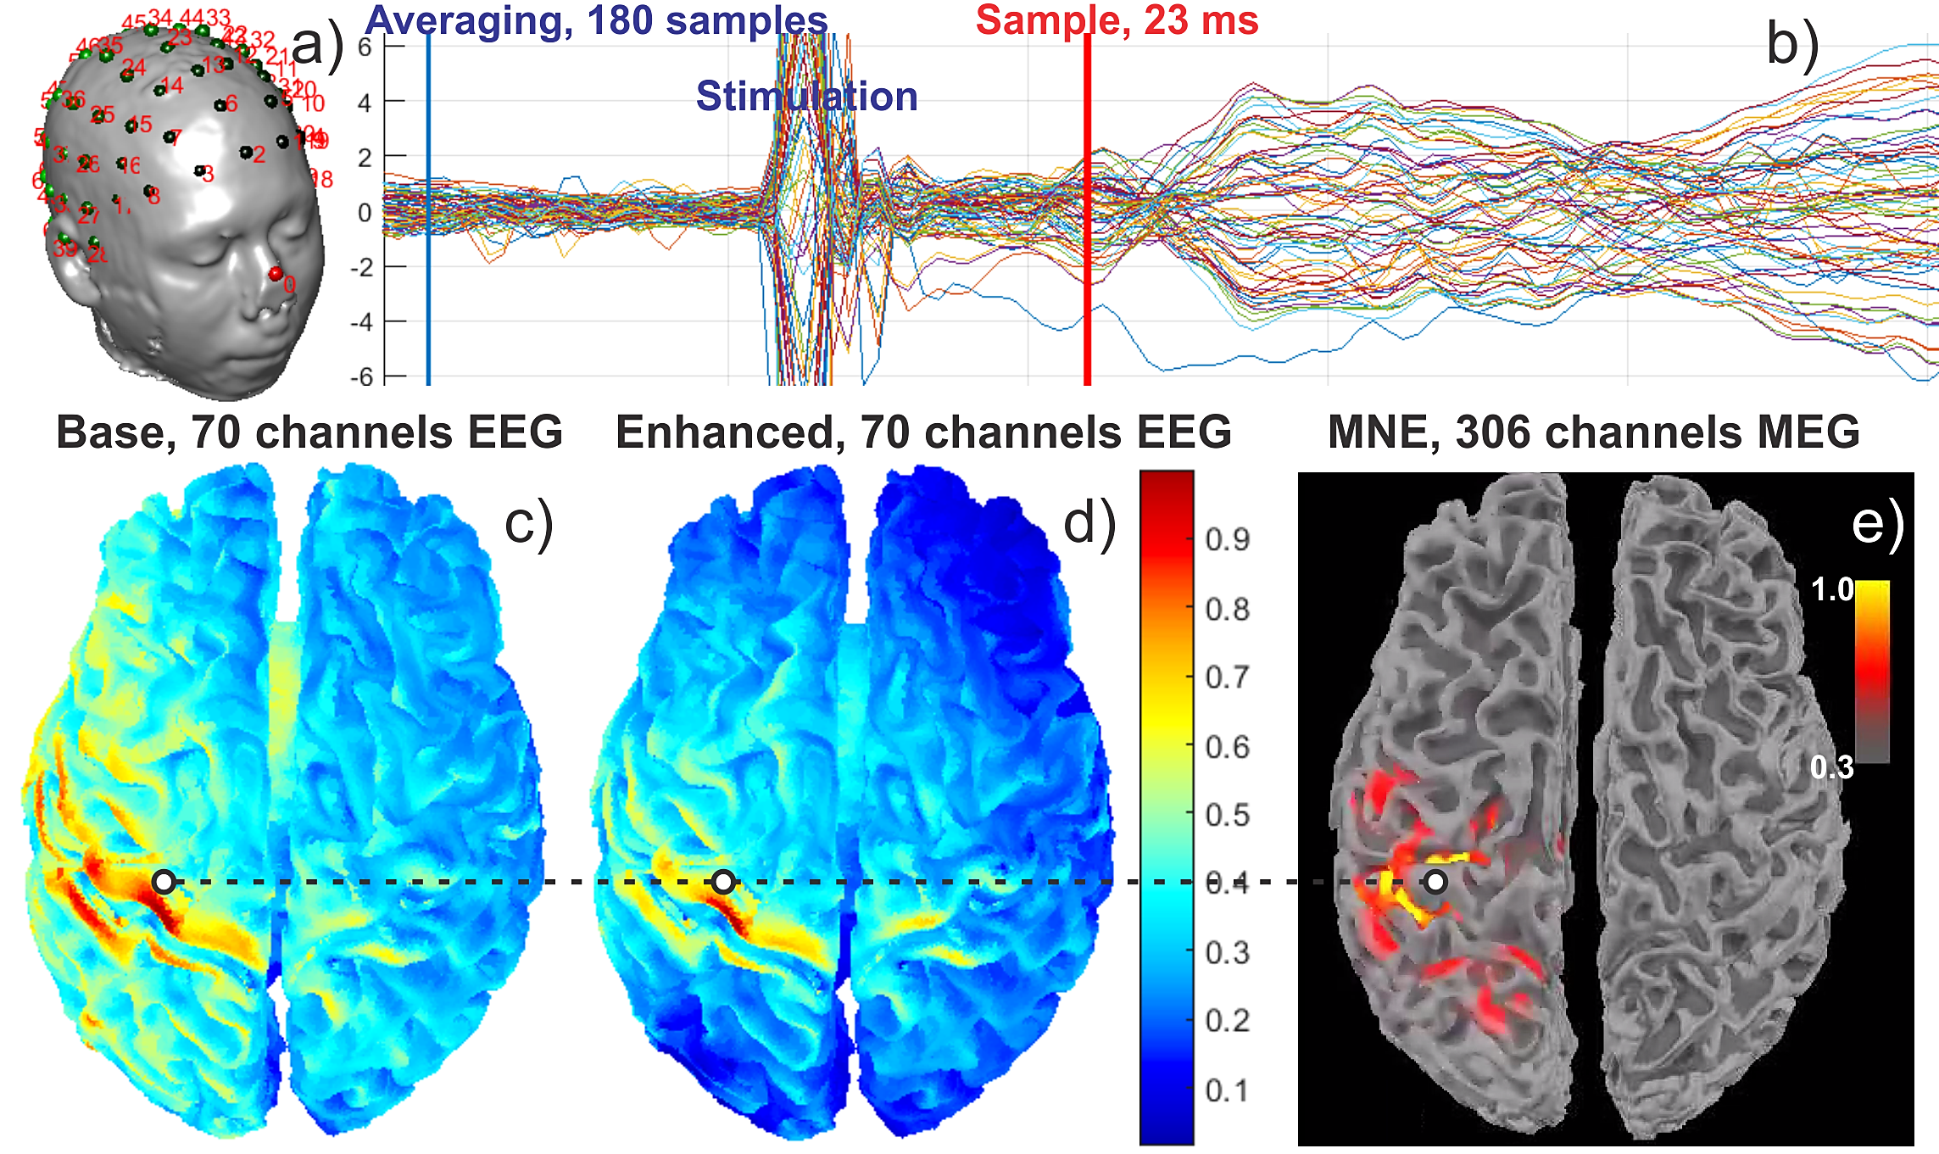

Fig. 13. a) Subject segmentation with registered EEG electrodes. b) Evoked response time courses from 70 EEG channels (nose reference). c) EEG source localization at 23 ms obtained with the base model. *Normalized* cortical dipole density is shown d) The same result but for the enhanced model using identical scale. e) MEG source localization (dSPM) obtained with MNE software. White dot shows the crown of $M_{1HAND}$ at precentral gyrus.

The PI and Dr. Raij then conducted a BEM-FMM source analysis which used base and enhanced subject models, respectively, constructed following Sections 2.3 and 2.4. Fig. 13a displays the electrode assembly, Fig. 13b shows the EEG evoked responses. Fig. 13c is the EEG source localization at 23 ms after the median nerve pulse obtained with the base model (headreco segmentation) and BEM-FMM using 0.25 M elementary cortical dipoles and the reciprocity principle. Normalized absolute cortical dipole density is plotted. Fig. 13d is the same result but obtained with the enhanced model and BEM-FMM, again with 0.25 M elementary cortical dipoles. Fig. 13e is an MEG source localization based on mri2mesh segmentation. It was obtained with MNE software [111],[112] and 5,000 cortical dipoles since BEM-FMM is not yet fitted for MEG source localization. Dynamic statistical parametric mapping (dSPM [122] i.e., noise-normalized dipolar source density) is plotted. All results are shown on the white matter surface. The white reference point in Figs. 13c,d,e is at the crown of the precentral gyrus ($M_{1HAND}$). Since MEG is most sensitive to generators in sulci (tangential source orientations) whereas EEG is sensitive to both gyral and sulcal sources (radial and tangential source orientations), the functional agreement between MEG and EEG data is very good for the enhanced model, whereas the base model leads to a spatially much more scattered EEG source configuration.

***2.11 Deliverable (Year 4)*.**A self-contained package based on the accessible MATLAB platform for Windows and Linux will be delivered via GitHub and a Dropbox folder of a larger capacity. Its structure is given in Fig. 14. *Preliminary versions* of the BEM-FMM solver for TMS, TES, EEG, and MEG (Windows, Linux, MATLAB platform, base model) have been made available on the Interagency Modeling and Analysis Group (IMAG) of NIH/NIBIB website and GitHub since 2020 [69]. They are in use by several domestic research groups and abroad.

**Aim 3. (Computational part) Develop BEM-FMM testbed for modeling activating function of microelectrodes and microcoils in animal axons.** The present testbed will generate or accept electrodes and coil CAD models as input and will output necessary stimulation fields and activating function with or without physical cellular models. Internally, it will also generate a target mesh for an axon or axonal fiber with or without myelination.

* Field output (line/surface/volume) for TMS/TES/ICMS
* Field tensor gradient output (line/surface/volume) for TMS/TES/ICMS
* Cortical dipole strength output (vertical + horizontal) for EEG/MEG

Headreco/mri2mesh input in *.stl format

TES CAD electrode imprinter

Enhanced model generator with any number of extra-cerebral compartments

20 head models: NIfTI plus base segmentations

TMS CAD coil geometry generator

ICMS CAD array generator

EEG (electrodes) and MEG (magn. dipoles) geometry generator

BEM-FMM engine

(with adaptive mesh ref.)

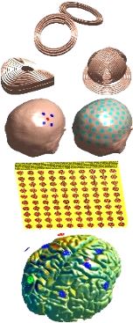

Fig. 14. Package structure. TMS/TES/ICMS and forward/inverse (*based on reciprocity*) EEG/MEG solvers will be available.

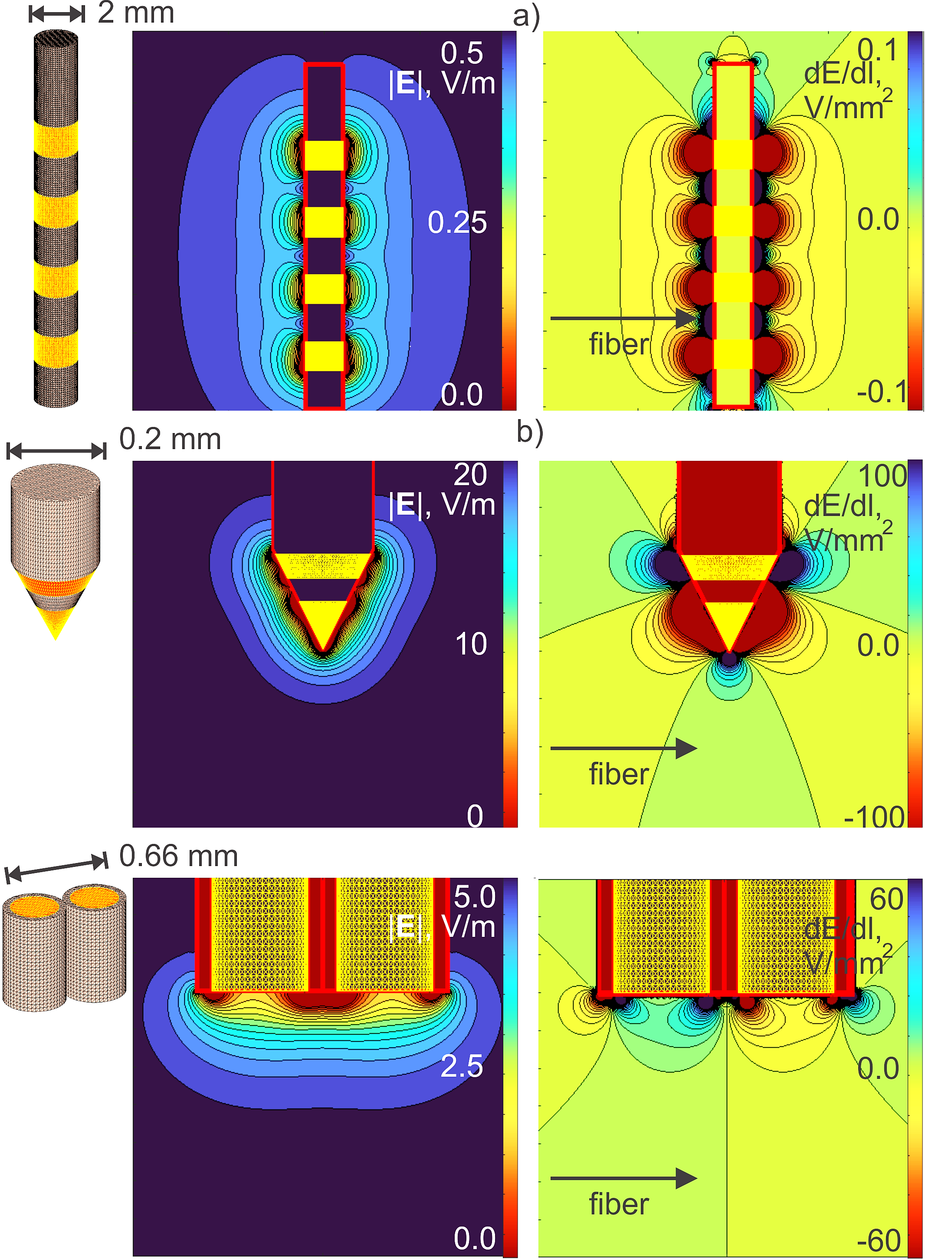

Fig. 15. Electric field and activating function ($dE/dl$) for three common electrode geometries: a) DBS electrode; b) conical electrode; c) twisted pair. Electrodes are at -1V in a) and at ±1V in b,c). Typical dimensions are shown.

***3.1 Concept of cellular-level BEM-FMM testbed.*** In contrast to the modern relevant software (FastField [25], NeMo-TMS [43]) our BEM-FMM testbed will introduce two new steps not possible before: (i) to directly compute (as shown in Section 1.3) and clearly visualize (Fig. 15) the activating function and (ii) to model the physical axons and dendrites and their blocking effect on the stimulation field itself introduced in the Significance section (Fig. 16). The stimulation field will be computed assuming a non-conducting cellular membrane condition [46]-[49] (end of initial polarization) and will allow us to find local activating function anywhere in space.

***3.2. Electrode/coil models and preliminary results.*** To support the experimental part of this aim, we deal with both electrical and magnetic stimulation. Micro coils for magnetic stimulation are created in the same way as the macro coils that are described elsewhere [123]. Fig. 15 shows realistic generic electrode models generated to date and their fields and activating functions in space.

To support the experimental part of this aim dealing with the compound action potential, we will introduce a mesh generator for tightly spaced parallel axonal fibers. Its preliminary version is shown in Fig. 16. The generator will create the membrane surface mesh and the myelin mesh for *every* axon with controlled spacing/randomization. FEM could hardly solve this biophysically relevant problem of compound action potential stimulation. An attempt to create an FEM volumetric mesh for the surface mesh from Fig. 16 in commercial FEM software Ansys Maxwell failed after 23 hours of work.

**Aim 3. (Verification part) Experimentally verify BEM-FMM testbed for modeling activating function in animal axons.** Biophysical verification will be performed with two “classic” experiments: action potential (AP) of a single crayfish giant axon [124],[125],[126] and compound action potential (CAP) of parallel fibers of turtle cerebellum [127],[128],[129]. Experiments will be performed in Sundaram laboratory of Martinos Ctr. for Biomedical Imaging by Dr. Sundaram and her team. Dr. Sundaram has a multiyear experience working with the turtle cerebellum [130]. In collaboration with the PI and Sub-PI, she has started micro-TES and TMS experiments and modeling to study cellular mechanisms of cerebellar stimulation in both turtle cerebellum in vitro and humans in vivo as a part of a Brain Initiative grant 1R01NS112183.

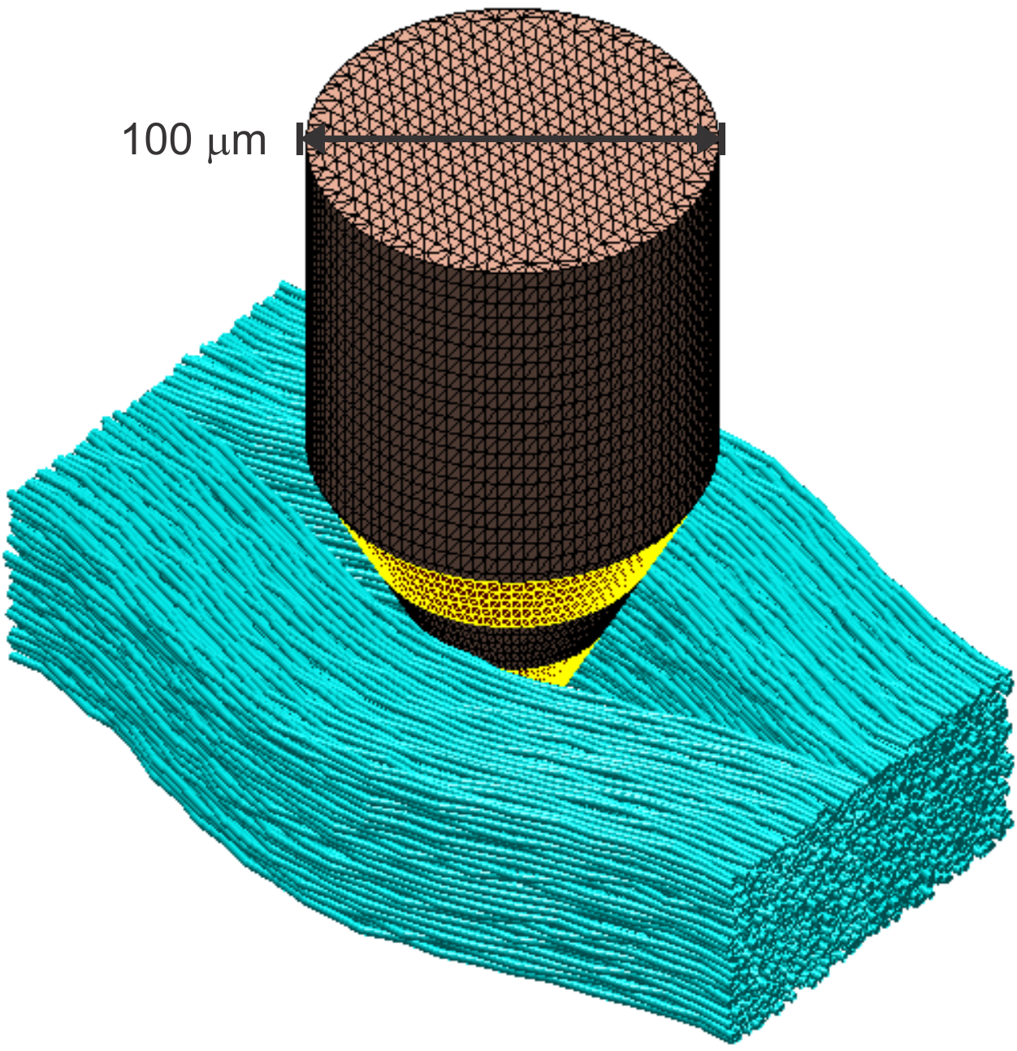

Fig. 16. Realistic concentric electrode to be embedded into parallel fibers of turtle cerebellum.

***3.3 Experiment and hypothesis for single neuron.*** The crayfish giant axon (Fig. 17) will be studied and stimulated first.

*Preparation.* Crayfish (*Procambarus clarkii*) will be purchased from Niles Biological Supplies (Sacramento CA). The ventral nerve cord is dissected out and is kept in physiological saline [131]. The ventral nerve cord contains 4 giant axons: two medial giants (MG) and two lateral giants (LG). The MG diameter is 125-250 um; the LG diameter is 100-150 um. The length of the dissected part is ~20 mm.

*Recording.* Giant axons are *not* myelinated and are independent. Stimulation of one never results in excitation of the other. We make a very small incision in the sheath and penetrate one of the axons with an intracellular glass micropipette electrode (Fig. 17b) under a microscope. Intracellular potential is then recorded as in Fig. 18.

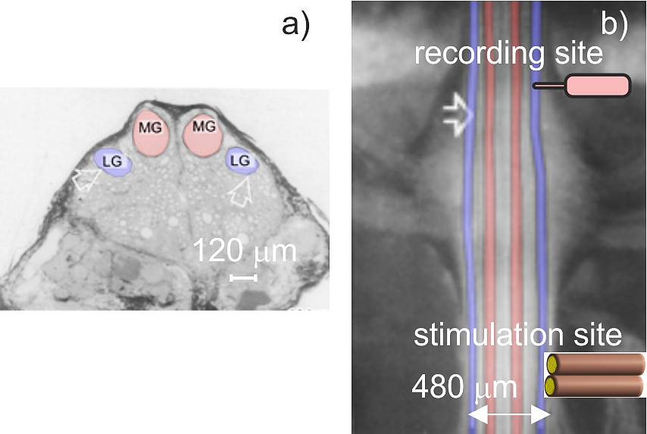

Fig. 17. a) Lateral cross-section of the ventral nerve cord showing medial giant (MG, in red) and lateral giant (LG, in blue) axons of crayfish. b) Rostro-caudal view of ventral nerve cord with stimulation and recording electrodes.

*Plan of experiment.* The axon is stimulated electrically by placing the twisted pair of Ag-AgCl wires (125 μm diameter) on its surface. For micro TMS, a TMS coil is placed under the Petri dish containing the axon. When the stimulus (electrical or TMS) is above the threshold, an action potential is recorded by the recording electrode. The identical setup with the twisted pair will be modeled by BEM-FMM as shown in Fig. 16a. The stimulus electric potential will be fed into NEURON software [66] using the “extracellular” mechanism with the space constant of 4.3 mm, membrane time constant of 3.1 ms, and membrane capacitance of 1.6 μF/cm2 [124],[125],[126]. This software internally computes the activating function by double differentiation of the stimulus potential. It will predict a current pulse level/duration required to generate the AP. The same current level/duration will be generated in experiments.

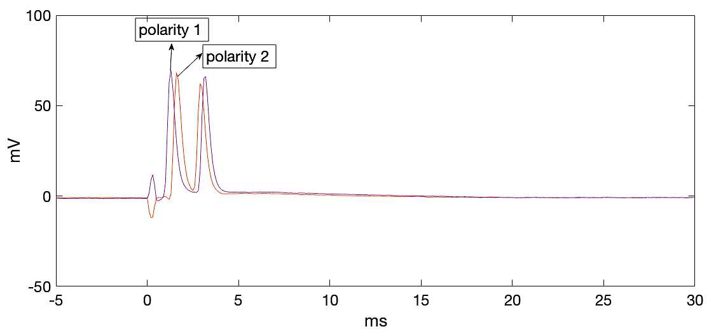

Fig. 18. A single 400 μs current pulse evokes two APs at a recording site a few mm away. Latency difference between the APs depends on the stimulus polarity.

*Hypothesis #1:* Predicted and measured current levels/pulse durations necessary for AP generation will agree with each other*.* Outcome: statistical data for 40 measurements.

***3.3 Experiment and hypothesis for compound action potential.*** Parallel fibers of the turtle cerebellum (Fig. 19) will be studied next.

*Preparation.* The surgical procedure is approved by our institution’s Subcommittee on Research Animal Care. The brain of the red-eared turtle (*Pseudemys Scripta Elegans*) is removed rapidly after decapitation and craniotomy and placed in cold Ringer’s solution. The whole intact cerebellum (inset in Fig. 19) including the peduncles is dissected away from the brainstem and the optic tectum under a microscope. We will use 20 animals.

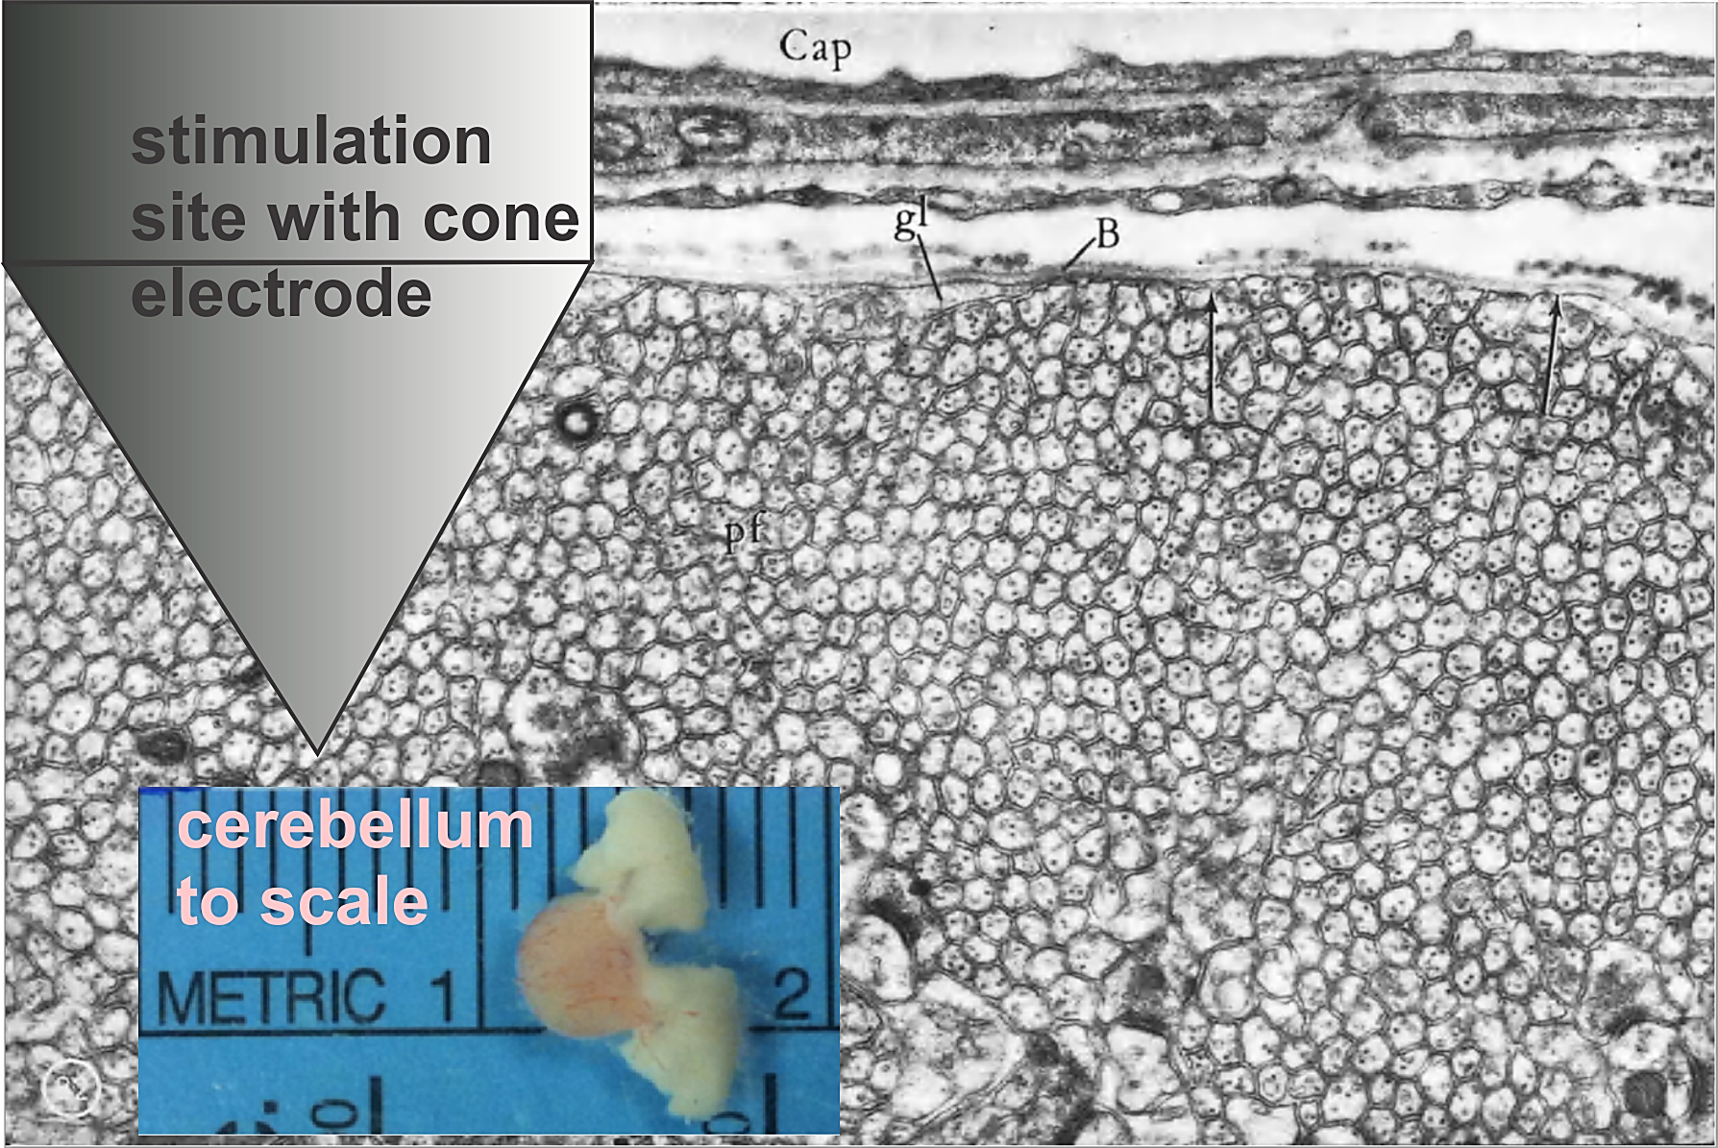

Fig. 19. Cross-section showing an almost crystalline array of parallel fibers filling the molecular layer [127] and concentric stimulation electrode. Fiber diameter is ~0.64 μm on average. Magnification L×20,000.

*Recording.* Extracellular recording of the compound action potential will be done using a glass micropipette electrode filled with 1M NaCl with the tip located anywhere in the molecular layer. The electrode will be carefully moved using a micromanipulator.

*Plan of experiment.* Parallel fibers are stimulated electrically by inserting the concentric (or cone) electrode in Fig. 19 (World Precision Instruments, FL) into the superficial molecular layer. When the stimulus is above the threshold, a compound action potential is recorded by the recording electrode. It will be placed at a fixed depth but at different distances from the stimulation site. The conduction speed in parallel fibers is ~0.25 m/s [129]. Based on this speed, we can predict latencies at different distances. The nearly identical setup with the conical concentric electrode surrounded by fibers will be modeled by BEM-FMM as shown in Fig. 16 at the initial polarization (non-conducting membranes) with taking into account axon myelination increase into the depth. The stimulus electric potential for every individua axon under question will be fed into NEURON software [66]. It will predict current pulse levels/durations required to generate CAPs. Based on the packing density of the parallel fibers (~0.64 um diameter) we will then predict the stimulated volume. The measured compound action potential (CAP) should be proportional to this volume.

*Hypothesis #2:* Predicted and measured CAPs at different distances from the activation site will behave similarly at the same pulse current/duration. Several different CAP measures will be attempted and quantified. We will carefully consider a jitter depending on different latencies. Outcome: statistical data for 20 animals.

***3.4 Deliverable (Year 5).*** A self-consistent BEM-FMM package for Micro TES and TMS stimulation containing a library of electrode/coil geometries, a basic CAD geometry generator, a generic model of parallel fibers with the electrode embedding option (this is likely even more important for accurate DBS modeling in human subjects) as well as experimental data will be based on the accessible MATLAB platform for Windows and Linux and will be delivered via GitHub and a Dropbox folder of a larger capacity.

**References**

1. FDA 510(k)/De Novo Clearance and Premarket Approval Applications: <https://www.accessdata.fda.gov/scripts/cdrh/cfdocs/search/default.cfm>, accessed Aug. 2021.
2. Jack CR Jr, Thompson RM, Butts RK, Sharbrough FW, Kelly PJ, Hanson DP, Riederer SJ, Ehman RL, Hangiandreou NJ, Cascino GD. Sensory motor cortex: correlation of presurgical mapping with functional MR imaging and invasive cortical mapping. *Radiology*. 1994 Jan;190(1):85-92. doi: 10.1148/radiology.190.1.8259434.
3. Grande KM, Ihnen SKZ, Arya R. Electrical Stimulation Mapping of Brain Function: A Comparison of Subdural Electrodes and Stereo-EEG. *Front Hum Neurosci*. 2020 Dec 7;14:611291. doi: 10.3389/fnhum.2020.611291.
4. Collavini S, Fernández Corazza M, Oddo S, Princich JP, Kochen S, Muravchik CH. Improvements on spatial coverage and focality of deep brain stimulation in pre-surgical epilepsy mapping. *J Neural Eng*. 2021 Feb 12. doi: 10.1088/1741-2552/abe5b9.
5. Crone NE, Miglioretti DL, Gordon B, Lesser RP. Functional mapping of human sensorimotor cortex with electrocorticographic spectral analysis. II. Event-related synchronization in the gamma band. *Brain*. 1998 Dec;121 ( Pt 12):2301-15. doi: 10.1093/brain/121.12.2301. PMID: 9874481.
6. Ramsey NF, van de Heuvel MP, Kho KH, Leijten FS. Towards human BCI applications based on cognitive brain systems: an investigation of neural signals recorded from the dorsolateral prefrontal cortex. *IEEE Trans Neural Syst Rehabil Eng.* 2006 Jun;14(2):214-7. doi: 10.1109/TNSRE.2006.875582.
7. Schalk G, Miller KJ, Anderson NR, Wilson JA, Smyth MD, Ojemann JG, Moran DW, Wolpaw JR, Leuthardt EC. Two-dimensional movement control using electrocorticographic signals in humans. *J Neural Eng*. 2008 Mar;5(1):75-84. doi: 10.1088/1741-2560/5/1/008.
8. Miller KJ, Schalk G, Fetz EE, den Nijs M, Ojemann JG, Rao RP. Cortical activity during motor execution, motor imagery, and imagery-based online feedback. *Proc Natl Acad Sci U S A.* 2010 Mar 2;107(9):4430-5. doi: 10.1073/pnas.0913697107. Erratum in: Proc Natl Acad Sci U S A. 2010 Apr 13;107(15):7113.
9. Yanagisawa T, Hirata M, Saitoh Y, Kishima H, Matsushita K, Goto T, Fukuma R, Yokoi H, Kamitani Y, Yoshimine T. Electrocorticographic control of a prosthetic arm in paralyzed patients. *Ann Neurol*. 2012 Mar;71(3):353-61. doi: 10.1002/ana.22613.
10. Vansteensel MJ, Pels EGM, Bleichner MG, Branco MP, Denison T, Freudenburg ZV, Gosselaar P, Leinders S, Ottens TH, Van Den Boom MA, Van Rijen PC, Aarnoutse EJ, Ramsey NF. Fully Implanted Brain-Computer Interface in a Locked-In Patient with ALS. *N Engl J Med*. 2016 Nov 24;375(21):2060-2066. doi: 10.1056/NEJMoa1608085.
11. Gent E, Adepoju P. COVID’s Mental-health toll: how scientists are tracking a surge in depression. *Nature Briefing*. 03 Feb. 2021. doi: <https://doi.org/10.1038/d41586-021-00175-z>. Online: <https://www.nature.com/articles/d41586-021-00175-z>
12. National Institutes of Mental Health (NIMH). *Major Depression*. Feb.2019. Online: <https://www.nimh.nih.gov/health/statistics/major-depression.shtml>.
13. Stern AP. *Transcranial magnetic stimulation (TMS): Hope for stubborn depression*. Harvard Health Publishing. Feb. 23 2018. Online: <https://www.health.harvard.edu/blog/transcranial-magnetic-stimulation-for-depression-2018022313335>
14. Saturnino GB, Puonti O, Nielsen JD, Antonenko D, Madsen KH, Thielscher A. SimNIBS 2.1: *A Comprehensive Pipeline for Individualized Electric Field Modelling for Transcranial Brain Stimulation*. 2019 Aug 28. In: Makarov S, Horner M, Noetscher G, editors. Brain and Human Body Modeling: Computational Human Modeling at EMBC 2018 [Internet]. Cham (CH): Springer; 2019. Chapter 1. PMID: 31725247.
15. Saturnino GB, Madsen KH, Thielscher A. Electric field simulations for transcranial brain stimulation using FEM: an efficient implementation and error analysis. *J Neural Eng.* 2019 Nov 6;16(6):066032. doi: 10.1088/1741-2552/ab41ba.
16. Saturnino GB, Thielscher A, Madsen KH, Knösche TR, Weise K. A principled approach to conductivity uncertainty analysis in electric field calculations. *Neuroimage*. 2019 Mar;188:821-834. doi: 10.1016/j.neuroimage.2018.12.053.
17. Huang Y, Datta A, Bikson M, Parra LC. Realistic volumetric-approach to simulate transcranial electric stimulation-ROAST-a fully automated open-source pipeline. *J Neural Eng.* 2019 Jul 30;16(5):056006. doi: 10.1088/1741-2552/ab208d.
18. SiRun. The NIH/NIGMS Center for Integrative Biomedical Computing. Online <https://www.sci.utah.edu/cibc-software/scirun.html>
19. Anderson DN, Osting B, Vorwerk J, Dorval AD, Butson CR. Optimized programming algorithm for cylindrical and directional deep brain stimulation electrodes. *J Neural Eng*. 2018 Apr;15(2):026005. doi: 10.1088/1741-2552/aaa14b.
20. Vorwerk J, Brock AA, Anderson DN, Rolston JD, Butson CR. A retrospective evaluation of automated optimization of deep brain stimulation parameters. *J Neural Eng*. 2019 Nov 6;16(6):064002. doi: 10.1088/1741-2552/ab35b1.
21. Duffley G, Anderson DN, Vorwerk J, Dorval AD, Butson CR. Evaluation of methodologies for computing the deep brain stimulation volume of tissue activated. *J Neural Eng.* 2019 Oct 29;16(6):066024. doi: 10.1088/1741-2552/ab3c95.
22. Athawale TM, Johnson KA, Butson CR, Johnson CR. A statistical framework for quantification and visualisation of positional uncertainty in deep brain stimulation electrodes. *Comput Methods Biomech Biomed Eng Imaging* *Vis*. 2019;7(4):438-449. doi: 10.1080/21681163.2018.1523750.
23. Åström M, Diczfalusy E, Martens H, Wårdell K. "Relationship between Neural Activation and Electric Field Distribution during Deep Brain Stimulation," *Ieee T Bio-Med Eng,* vol. 62, no. 2, pp. 664-672, Feb 2015.
24. Johansson JD, Alonso F., Wårdell K. "Modelling details for electric field simulations of deep brain stimulation," in *World Congress on Medical Physics & Biomedical Engineering*, Prague, 2018, vol. 68, no. 1: Springer, pp. 645-648.
25. Baniasadi M, Proverbio D, Gonçalves J, Hertel F, Husch A. FastField: An open-source toolbox for efficient approximation of deep brain stimulation electric fields. *Neuroimage.* 2020 Dec;223:117330. doi: 10.1016/j.neuroimage.2020.117330.
26. Wenger C, Miranda PC, Salvador R, Thielscher A, Bomzon Z, Giladi M, Mrugala MM, Korshoej AR. A Review on Tumor-Treating Fields (TTFields): Clinical Implications Inferred From Computational Modeling. *IEEE Rev. Biomed Eng*. 2018;11:195-207. doi: 10.1109/RBME.2017.2765282. Epub 2018 Feb 13. PMID: 29993870.
27. Tadel, F., Baillet, S., Mosher, J.C. et al. (2011). Brainstorm: A User-Friendly Application for MEG/EEG Analysis. *Comput Intell Neurosci*., 2011:879716. doi: 10.1155/2011/879716.
28. Oostenveld, R., Fries, P., Maris, E., et al. (2011). FieldTrip: Open Source Software for Advanced Analysis of MEG, EEG, and Invasive Electrophysiological Data. *Comput Intell Neurosci*., 2011:156869. doi: 10.1155/2011/156869.
29. Schrader S, Westhoff A, Piastra MC, Miinalainen T, Pursiainen S, Vorwerk J, Brinck H, Wolters CH, Engwer C. DUNEuro-A software toolbox for forward modeling in bioelectromagnetism. *PLoS One*. 2021 Jun 4;16(6):e0252431. doi: 10.1371/journal.pone.0252431.
30. Engwer C, Vorwerk J, Ludewig J, Wolters CH. A Discontinuous Galerkin Method to Solve the EEG Forward Problem Using the Subtraction Approach. *SIAM J. Sci. Comput*. 2017;39(1): B138–B164. doi. 10.1137/15M1048392.
31. Piastra MC, Nüßing A, Vorwerk J, Bornfleth H, Oostenveld R, Engwer C, Wolters CH. The Discontinuous Galerkin Finite Element Method for Solving the MEG and the Combined MEG/EEG Forward Problem. *Frontiers in Neuroscience*. 2018;12(Article 30):1-18. doi: 10.3389/fnins.2018.00030.
32. Makarov SN, Noetscher GM, Raij T, Nummenmaa A. A Quasi-Static Boundary Element Approach with Fast Multipole Acceleration for High-Resolution Bioelectromagnetic Models. *IEEE Trans Biomed Eng*. 2018 Mar 7. doi: 10.1109/TBME.2018.2813261.
33. Htet AT, Saturnino GB, Burnham EH, Noetscher G, Nummenmaa A, Makarov SN. Comparative performance of the finite element method and the boundary element fast multipole method for problems mimicking transcranial magnetic stimulation (TMS). *J Neural Eng*. 2019 Apr;16(2):024001. doi: 10.1088/1741-2552/aafbb9.
34. Makarov SN, Wartman WA, Daneshzand M, Fujimoto K, Raij T, Nummenmaa A. A software toolkit for TMS electric-field modeling with boundary element fast multipole method: An efficient MATLAB implementation. *J Neural Eng.* 2020 Apr 1. doi: 10.1088/1741-2552/ab85b3.
35. Makarov SN, Hämäläinen M, Okada Y, Noetscher GM, Ahveninen J, Nummenmaa A. Boundary Element Fast Multipole Method for Enhanced Modeling of Neurophysiological Recordings. *IEEE Trans. Biomed. Eng.* 2020 May 29. doi: 10.1109/TBME.2020.2999271.
36. Makarov SN, Golestani Rad L, Wartman WA, Nguyen BT, Noetscher G, Ahveninen JP, Fujimoto K, Weise K, Nummenmaa A. Boundary element fast multipole method for modeling electrical brain stimulation with voltage and current electrodes. *J Neural Eng.* 2021 Jul 26. doi: 10.1088/1741-2552/ac17d7.
37. Iacono MI, Neufeld E, Akinnagbe E, Bower K, Wolf J, Vogiatzis Oikonomidis I, Sharma D, Lloyd B, Wilm BJ, Wyss M, Pruessmann KP, Jakab A, Makris N, Cohen ED, Kuster N, Kainz W, Angelone LM. MIDA: A Multimodal Imaging-Based Detailed Anatomical Model of the Human Head and Neck. *PLoS One*. 2015 Apr 22;10(4):e0124126. doi: 10.1371/journal.pone.0124126.
38. Farcito S, Lloyd BA, Thielscher A, Puonti O, Montanaro H, Saturnino GB, Nielsen JD, Madsen CG, Siebner HR, Neufeld E, Kuster N. Accurate anatomical head segmentations: a data set for biomedical simulations. *Annu Int Conf IEEE Eng Med Biol Soc*. 2019 Jul;2019:6118-6123. doi: 10.1109/EMBC.2019.8857041.
39. W. A. Wartrnan, E. H. Burnham, S. N. Makarov, M. Davids, M. Daneshzand and A. Nummenmaa, "High Resolution Computational Modeling of Transcranial Stimulation using the MIDA Head Model," *2021 10th International IEEE/EMBS Conference on Neural Engineering (NER)*, 2021, pp. 1044-1047, doi: 10.1109/NER49283.2021.9441170.
40. Gabriel C. Compilation of the Dielectric Properties of Body Tissues at RF and Microwave Frequencies, *Report N.AL/OE-TR- 1996-0037*, Occupational and environmental health directorate, Radiofrequency Radiation Division, Brooks Air Force Base, Texas (USA), 1996. Online: <https://itis.swiss/virtual-population/tissue-properties/database/low-frequency-conductivity/>
41. Riel S., Bashiri M., Hemmert W., Bai S. (2021) Computational Models of Brain Stimulation with Tractography Analysis. In: Makarov S.N., Noetscher G.M., Nummenmaa A. (eds) *Brain and Human Body Modeling* 2020. Springer, Cham. <https://doi.org/10.1007/978-3-030-45623-8_6>
42. Næss S, Halnes G, Hagen E, Hagler DJ Jr, Dale AM, Einevoll GT, Ness TV. Biophysically detailed forward modeling of the neural origin of EEG and MEG signals. *Neuroimage*. 2021 Jan 15;225:117467. doi: 10.1016/j.neuroimage.2020.117467.
43. Shirinpour S, Hananeia N, Rosado J, Tran H, Galanis C, Vlachos A, Jedlicka P, Queisser G, Opitz A. Multi-scale modeling toolbox for single neuron and subcellular activity under Transcranial Magnetic Stimulation. *Brain Stimul*. 2021 Sep 22:S1935-861X(21)00234-5. doi: 10.1016/j.brs.2021.09.004.
44. Aberra AS, Peterchev AV, Grill WM. Biophysically realistic neuron models for simulation of cortical stimulation. *J Neural Eng.* 2018 Dec;15(6):066023. doi: 10.1088/1741-2552/aadbb1.
45. Wang B, Grill WM, Peterchev AV. Coupling Magnetically Induced Electric Fields to Neurons: Longitudinal and Transverse Activation. *Biophys J*. 2018 Jul 3;115(1):95-107. doi: 10.1016/j.bpj.2018.06.004
46. Koch C, Jones A. Big Science, Team Science, and Open Science for Neuroscience. *Neuron*. 2016 Nov 2;92(3):612-616. doi: 10.1016/j.neuron.2016.10.019. Online database: <http://neuromorpho.org/>.
47. Klee M, Plonsey R. Stimulation of spheroidal cells-The role of cell shape. 1976. *IEEE Trans Biomed Eng*. Jul;23(4):347-54. PMID: 1278928.
48. Cartee LA, Plonsey R. The transient subthreshold response of spherical and cylindrical cell models to extracellular stimulation. *IEEE Trans Biomed Eng*. 1992 Jan;39(1):76-85. DOI: 10.1109/10.108130.

1. [Krassowska W](https://www.ncbi.nlm.nih.gov/pubmed/?term=Krassowska%20W%5BAuthor%5D&cauthor=true&cauthor_uid=8075318), [Neu JC](https://www.ncbi.nlm.nih.gov/pubmed/?term=Neu%20JC%5BAuthor%5D&cauthor=true&cauthor_uid=8075318). Response of a single cell to an external electric field. [*Biophys J.*](https://www.ncbi.nlm.nih.gov/pubmed/8075318)1994 Jun;66(6):1768-76. doi: [10.1016/S0006-3495(94)80971-3](https://doi.org/10.1016/S0006-3495(94)80971-3).
2. Pourtaheri N, Ying W, Kim JM, Henriquez CS. Thresholds for transverse stimulation: fiber bundles in a uniform field. *IEEE Trans Neural Syst Rehabil Eng*. 2009 Oct;17(5):478-86. doi: 10.1109/TNSRE.2009.2033424.
3. Rattay F. Analysis of the electrical excitation of CNS neurons. *IEEE Trans. Biomed. Eng*. 1998;45 (6): 766–772. doi:10.1109/10.67861.
4. Ruohonen J, Panizza M, Nilsson J, Ravazzani P, Grandori F, Tognola G. Transverse-field activation mechanism in magnetic stimulation of peripheral nerves. *Electroencephalogr Clin Neurophysiol*. 1996 Apr;101(2):167-74. doi: 10.1016/0924-980x(95)00237-f.
5. Rattay F. The basic mechanism for the electrical stimulation of the nervous system. Neuroscience. 1999 Mar;89(2):335-46. doi: 10.1016/s0306-4522(98)00330-3. PMID: 10077317.
6. Wang B, Grill WM, Peterchev AV. Coupling Magnetically Induced Electric Fields to Neurons: Longitudinal and Transverse Activation. *Biophys J*. 2018 Jul 3;115(1):95-107. doi: 10.1016/j.bpj.2018.06.004.
7. Tomassy GS, Berger DR, Chen HH, Kasthuri N, Hayworth KJ, Vercelli A, Seung HS, Lichtman JW, Arlotta P. Distinct profiles of myelin distribution along single axons of pyramidal neurons in the neocortex*. Science*. 2014 Apr 18;344(6181):319-24. doi: 10.1126/science.1249766. PMID: 24744380; PMCID: PMC4122120.
8. Ansys, Inc. Canonsburg, PA, U.S.A. *Corporate website*. Online: <https://www.ansys.com/>
9. D. Schaubert, D. Wilton and A. Glisson, "A tetrahedral modeling method for electromagnetic scattering by arbitrarily shaped inhomogeneous dielectric bodies," *IEEE Transactions on Antennas and Propagation*, vol. 32, no. 1, pp. 77-85, January 1984, doi: 10.1109/TAP.1984.1143193.
10. Greengard L, Rokhlin V. A fast algorithm for particle simulations. *J. Comput. Phys.* 1987;73(2):325-348. doi: 10.1016/0021-9991(87)90140-9.
11. Gimbutas Z, Greengard L, Magland J, Rachh M, Rokhlin V. *fmm3D Documentation.* Release 0.1.0. 2019-2021. Online: https://github.com/flatironinstitute/FMM3D & <https://github.com/flatironinstitute/FMM3D/blob/master/fmm3d_manual.pdf>.
12. Knösche TR and Dannhauer M (2010). Electromagnetic Modeling of the Human Skull using Finite Elements.*Front. Neurosci. Conference Abstract: Biomag 2010 - 17th International Conference on Biomagnetism .*doi: 10.3389/conf.fnins.2010.06.00044.
13. Dannhauer M, Lanfer B, Wolters CH, Knösche TR. Modeling of the human skull in EEG source analysis. *Hum Brain Mapp*. 2011 Sep;32(9):1383-99. doi: 10.1002/hbm.21114.
14. Jiang J, Truong DQ, Esmaeilpour Z, Huang Y, Badran BW, Bikson M. Enhanced tES and tDCS computational models by meninges emulation. *J Neural Eng*. 2020 Jan 14;17(1):016027. doi: 10.1088/1741-2552/ab549d.
15. Khadka N, Bikson M. Role of skin tissue layers and ultra-structure in transcutaneous electrical stimulation including tDCS. *Phys Med Biol*. 2020 Nov 24;65(22):225018. doi: 10.1088/1361-6560/abb7c1. PMID: 32916670.
16. W. A. Wartrnan, E. H. Burnham, S. N. Makarov, M. Davids, M. Daneshzand and A. Nummenmaa, "High Resolution Computational Modeling of Transcranial Stimulation using the MIDA Head Model," *2021 10th International IEEE/EMBS Conference on Neural Engineering (NER)*, 2021, pp. 1044-1047, doi: 10.1109/NER49283.2021.9441170.
17. Baniasadi M, Proverbio D, Gonçalves J, Hertel F, Husch A. FastField: An open-source toolbox for efficient approximation of deep brain stimulation electric fields. *Neuroimage.* 2020 Dec;223:117330. doi: 10.1016/j.neuroimage.2020.117330.
18. Carnevale, N., & Hines, M. (2006). *The NEURON Book*. Cambridge: Cambridge University Press. doi:10.1017/CBO9780511541612
19. Makarov SN, Noetscher GM, Nazarian A. *Low-Frequency Electromagnetic Modeling for Electrical and Biological Systems Using MATLAB*, Wiley, New York 2015. 648 p. ISBN-10: 1119052564.
20. *Interagency Modeling and Analysis Group (IMAG) Repository. NIH. NIBIB*. Accessed 09/18/21. Online: <https://www.imagwiki.nibib.nih.gov/>
21. Makarov S., Wartman W. Nummenmaa A. Boundary Element Fast Multipole Method (BEM-FMM) for Bioelectromagnetic Modeling of the Brain. *Interagency Modeling and Analysis Group (IMAG). NIH. NIBIB*. Online: <https://www.imagwiki.nibib.nih.gov/resource_credibility_assessment/boundary-element-fast-multipole-method-bem-fmm-bioelectromagnetic>.
22. Vorwerk J, Engwer C, Pursiainen S, Wolters CH. A Mixed Finite Element Method to Solve the EEG Forward Problem. *IEEE Trans Med Imaging*. 2017 Apr;36(4):930-941. doi: 10.1109/TMI.2016.2624634. Epub 2016 Nov 2. PMID: 27831869.
23. Engwer C, Vorwerk J, Ludewig J, Wolters CH. A Discontinuous Galerkin Method to Solve the EEG Forward Problem Using the Subtraction Approach. *SIAM J. Sci. Comput*. 2017;39(1): B138–B164. doi. 10.1137/15M1048392.
24. Piastra MC, Nüßing A, Vorwerk J, Bornfleth H, Oostenveld R, Engwer C, Wolters CH. The Discontinuous Galerkin Finite Element Method for Solving the MEG and the Combined MEG/EEG Forward Problem. *Frontiers in Neuroscience*. 2018;12(Article 30):1-18. doi: 10.3389/fnins.2018.00030.
25. Sarvas J. Basic mathematical and electromagnetic concepts of the biomagnetic inverse problem. *Phys. Med. Biol.* 1987 Jan; 32(1):11-22. PMID: 3823129.
26. Imbert-Gerard LM, Vico F, Greengard L, Ferrando M. Integral Equation Methods for Electrostatics, Acoustics, and Electromagnetics in Smoothly Varying, Anisotropic Media . *SIAM J. Numer. Anal*., 57(3), 2019, 1020–1035. doi: <https://doi.org/10.1137/18M1187039>
27. Monin M, Rahmouni L, Andriulli F. A Hybrid Integral Equation Approach to Solve the Anisotropic Forward Problem in Electroencephalography. *2018 IEEE International Symposium on Antennas and Propagation & USNC/URSI National Radio Science Meeting*, Jul 2018, Boston, pp.2395-2396, 10.1109/APUSNCURSINRSM.2018.8608390. <https://hal.archives-ouvertes.fr/hal-02553093>
28. Lunkenheimer P. Comparison of BEM-FMM and CG-FEM approaches for forward problems of EEG. *Brain & Human Body Modeling Int. Conf. 2021*. MGH, Boston MA, Online (PWD BHBM2021): <https://www.dropbox.com/sh/7p7jzk5ij981zha/AABcHTCNS83aBbBOCbh6zLNfa?dl=0>.
29. Saturnino GB, Wartman WA, Makarov SN, Thielscher A. Accurate TMS Head Modeling: Interfacing SimNIBS and BEM-FMM in a MATLAB-Based Module. *Annu Int Conf IEEE Eng Med Biol Soc. 2020* Jul;2020:5326-5329. doi: 10.1109/EMBC44109.2020.9175802.
30. Puzyrev V, Cela José María. A review of block Krylov subspace methods for multisource electromagnetic modellin., *Geophysical Journal International*, Volume 202, Issue 2, August 2015, Pages 1241–1252, <https://doi.org/10.1093/gji/ggv216>.
31. Fischl B. FreeSurfer. *NeuroImage*. 2012;62(2):774-81. doi: 10.1016/j.neuroimage.2012.01.021. PubMed PMID: 22248573.
32. FreeSurfer Software Suite. Online: <https://www.zotero.org/freesurfer>; FreeSurfer Subcortical Segmentation Accuracy. Online: <http://freesurfer.net/fswiki/SubcorticalSegmentationAccuracy>; FreeSurfer Update 2019-04-03. Online: <https://surfer.nmr.mgh.harvard.edu/fswiki/MorphometryStats>
33. Jenkinson M, Beckmann CF, Behrens TE, Woolrich MW, Smith SM. FSL. Neuroimage. 2012 Aug 15;62(2):782-90. doi: 10.1016/j.neuroimage.2011.09.015. Epub 2011 Sep 16. PMID: 21979382.
34. *Structural Brain Mapping Group. Computational Anatomy Toolbox (CAT)*. Univ. of Jena, Germany. Accessed 04/05/21. Online: <http://www.neuro.uni-jena.de/wordpress/publications/>
35. Puonti O, Van Leemput K, Saturnino GB, Siebner HR, Madsen KH, Thielscher A. Accurate and robust whole-head segmentation from magnetic resonance images for individualized head modeling. *Neuroimage*. 2020 Oct 1;219:117044. doi: 10.1016/j.neuroimage.2020.117044.
36. Kozlov M, Horner M, Kainz W, Weiskopf N, Möller HE. Modeling radio-frequency energy-induced heating due to the presence of transcranial electric stimulation setup at 3T. *MAGMA*. 2020 Dec;33(6):793-807. doi: 10.1007/s10334-020-00853-5.
37. Boruah S, Paskoff GR, Shender BS, Subit DL, Salzar RS, Crandall JR. Variation of bone layer thicknesses and trabecular volume fraction in the adult male human calvarium. *Bone*. 2015 Aug;77:120-34. doi: 10.1016/j.bone.2015.04.031.
38. Lillie EM, Urban JE, Weaver AA, Powers AK, Stitzel JD. Estimation of skull table thickness with clinical CT and validation with microCT. *J Anat.* 2015 Jan;226(1):73-80. doi: 10.1111/joa.12259. Epub 2014 Dec 1. PMID: 25441171; PMCID: PMC4313900.
39. Lynnerup N, Astrup JG, Sejrsen B. Thickness of the human cranial diploe in relation to age, sex and general body build. *Head Face Med*. 2005 Dec 20;1:13. doi: 10.1186/1746-160X-1-13.
40. Lillie EM, Urban JE, Lynch SK, Weaver AA, Stitzel JD. Evaluation of Skull Cortical Thickness Changes With Age and Sex From Computed Tomography Scans*. J Bone Miner Res.* 2016 Feb;31(2):299-307. doi: 10.1002/jbmr.2613.
41. Alexander SL, Rafaels K, Gunnarsson CA, Weerasooriya T. Morphological Characterization of the Frontal and Parietal Bones of the Human Skull. *US Army Research Lab*. ARL-TR- 7962 MAR 2017. Online: [https://apps.dtic.mil/sti/pdfs/AD1029208.pdf. Accessed 08/29/21](https://apps.dtic.mil/sti/pdfs/AD1029208.pdf.%20Accessed%2008/29/21).
42. Gomez LJ, Dannhauer M, Koponen LM, Peterchev AV. Conditions for numerically accurate TMS electric field simulation. *Brain Stimul*. 2019 Oct 3. pii: S1935-861X(19)30378-X. doi: 10.1016/j.brs.2019.09.015.
43. Iacono MI, Neufeld E, Akinnagbe E, Bower K, Wolf J, Vogiatzis Oikonomidis I, Sharma D, Lloyd B, Wilm BJ, Wyss M, Pruessmann KP, Jakab A, Makris N, Cohen ED, Kuster N, Kainz W, Angelone LM. MIDA: A Multimodal Imaging-Based Detailed Anatomical Model of the Human Head and Neck. *PLoS One*. 2015 Apr 22;10(4):e0124126. doi: 10.1371/journal.pone.0124126.
44. Lüsebrink F, Sciarra A, Mattern H, Yakupov R, Speck O. T1-weighted in vivo human whole brain MRI dataset with an ultrahigh isotropic resolution of 250 μm. *Sci Data*. 2017 Mar 14;4:170032. doi: 10.1038/sdata.2017.32. Erratum in: Sci Data. 2017 May 09;4:170062. PMID: 28291265; PMCID: PMC5349250.
45. Wang F, Dong Z, Tian Q, Liao C, Fan Q, Hoge WS, Keil B, Polimeni JR, Wald LL, Huang SY, Setsompop K. In vivo human whole-brain Connectom diffusion MRI dataset at 760 µm isotropic resolution. Sci Data. 2021 Apr 29;8(1):122. doi: 10.1038/s41597-021-00904-z.
46. Hibert ML, Chen YI, Ohringer N, Feuer WJ, Waheed NK, Heier JS, Calhoun MW, Rosenfeld PJ, Polimeni JR. Altered Blood Flow in the Ophthalmic and Internal Carotid Arteries in Patients with Age-Related Macular Degeneration Measured Using Noncontrast MR Angiography at 7T. AJNR Am J Neuroradiol. 2021 Jul 1. doi: 10.3174/ajnr.A7187.
47. Van Essen DC, Ugurbil K, Auerbach E, Barch D, Behrens TE, Bucholz R, Chang A, Chen L, Corbetta M, Curtiss SW, Della Penna S, Feinberg D, Glasser MF, Harel N, Heath AC, Larson-Prior L, Marcus D, Michalareas G, Moeller S, Oostenveld R, Petersen SE, Prior F, Schlaggar BL, Smith SM, Snyder AZ, Xu J, Yacoub E. The Human Connectome Project: A data acquisition perspective. *NeuroImage*. 2012; **62**(4):2222–2231. Online (Jan. 2020): <http://www.humanconnectomeproject.org/>
48. Rashed EA, Gomez-Tames J, Hirata A. **Development of accurate human head models for personalized electromagnetic dosimetry using deep learning** *Neuroimage* (2019), doi:[10.1016/j.neuroimage.2019.116132](https://doi.org/10.1016/j.neuroimage.2019.116132)
49. Bashkatov AN, Genina EA, Sinichkin YP, Kochubey VI, Lakodina NA, Tuchin VV. Glucose and mannitol diffusion in human dura mater. *Biophys J*. 2003 Nov;85(5):3310-8. doi: 10.1016/S0006-3495(03)74750-X.
50. Kuchiwaki H, Inao S, Ishii N, Ogura Y, Gu SP. Human dural thickness measured by ultrasonographic method: reflection of intracranial pressure. *J Ultrasound Med*. 1997 Nov;16(11):725-30. doi: 10.7863/jum.1997.16.11.725.
51. Saboori P, Sadegh A. Histology and Morphology of the Brain Subarachnoid Trabeculae. *Anat Res Int.* 2015;2015:279814. doi: 10.1155/2015/279814.
52. Fournier M, Combès B, Roberts N, Braga J and Prima S 2011. Mapping the distance between the brain and the inner surface of the skull and their global asymmetries *Medical Imaging 2011*: Image Processing Medical Imaging 2011: Image Processing vol 7962 (International Society for Optics and Photonics; ) p 79620Y.
53. Makarov SN, Wartman WA, Noetscher GM, Fujimoto K, Zaidi T, Burnham EH, Daneshzand M, Nummenmaa A. Degree of improving TMS focality through a geometrically stable solution of an inverse TMS problem. *NeuroImage*. 2021 Jul 28;241:118437. doi: 10.1016/j.neuroimage.2021.118437.
54. Saturnino GB, Puonti O, Nielsen JD, Antonenko D, Madsen KH, Thielscher A. SimNIBS 2.1: A Comprehensive Pipeline for Individualized Electric Field Modelling for Transcranial Brain Stimulation. In: Makarov S, Noetscher G, Horner M. Eds. *Brain and Human Body Modeling*. Springer Nature. NY 2019. ISBN 9783030212926.
55. R.C. Oldfield, The assessment and analysis of handedness: the Edinburgh inventory, *Neuropsychologia* 9 (1) (1971) 97–113.
56. Rossi S, Hallett M, Rossini PM, Pascual-Leone A. Safety of TMS Consensus Group. Safety, ethical considerations, and application guidelines for the use of transcranial magnetic stimulation in clinical practice and research. *Clin Neurophysiol*. 2009 Dec;**120**(12):2008-2039. doi: 10.1016/j.clinph.2009.08.016.
57. Lefaucheur JP, André-Obadia N, Antal A, Ayache SS, Baeken C, Benninger DH, Cantello RM, Cincotta M, de Carvalho M, De Ridder D, Devanne H, Di Lazzaro V, Filipović SR, Hummel FC, Jääskeläinen SK, Kimiskidis VK, Koch G, Langguth B, Nyffeler T, Oliviero A, Padberg F, Poulet E, Rossi S, Rossini PM, Rothwell JC, Schönfeldt-Lecuona C, Siebner HR, Slotema CW, Stagg CJ, Valls-Sole J, Ziemann U, Paulus W, Garcia-Larrea L. Evidence-based guidelines on the therapeutic use of repetitive transcranial magnetic stimulation (rTMS). *Clin Neurophysiol*. 2014 Nov;**125**(11):2150-2206. doi: 10.1016/j.clinph.2014.05.021.
58. van der Kouwe AJW, Benner T, Salat DH, Fischl B. Brain morphometry with multiecho MPRAGE. *NeuroImage*. 2008;40(2):559-69. doi: 10.1016/j.neuroimage.2007.12.025. PubMed PMID: 18242102; PMCID: PMC2408694.
59. Lichy MP, Wietek BM, Mugler JP, Horger W, Menzel MI, Anastasiadis A, Siegmann K, Niemeyer T, Königsrainer A, Kiefer B, Schick F, Claussen CD, Schlemmer H-P. Magnetic resonance imaging of the body trunk using a single-slab, 3-dimensional, T2-weighted turbo-spin-echo sequence with high sampling efficiency (SPACE) for high spatial resolution imaging: initial clinical experiences. *Investigative Radiology*. 2005;40(12):754- 60. PubMed PMID: 16304477.
60. Htet AT, Burnham EH, Noetscher GM, Pham DN, Nummenmaa A, Makarov SN. Collection of CAD human head models for electromagnetic simulations and their applications. *Biomedical Physics & Engineering Express*. 2019: 6(5):1-13. doi: <https://doi.org/10.1088/2057-1976/ab4c76>.
61. Raij T, Karhu J, Kicić D, Lioumis P, Julkunen P, Lin FH, Ahveninen J, Ilmoniemi RJ, Mäkelä JP, Hämäläinen M, Rosen BR, Belliveau JW. Parallel input makes the brain run faster. *Neuroimage*. 2008 May 1;40(4):1792-7. doi: 10.1016/j.neuroimage.2008.01.055.
62. Liu Y, Rui J, Gao K, Lao J. Variable innervation of the first dorsal interosseous muscle: an electrophysiological study. *Ann Transl Med*. 2020 Dec;8(23):1563. doi: 10.21037/atm-20-1466.
63. Gramfort A, Luessi M, Larson E, Engemann DA, Strohmeier D, Brodbeck C, Goj R, Jas M, Brooks T, Parkkonen L, Hämäläinen M. MEG and EEG data analysis with MNE-Python. *Front Neurosci*. 2013 Dec 26;7:267. doi: 10.3389/fnins.2013.00267.
64. Gramfort A, Luessi M, Larson E, Engemann DA, Strohmeier D, Brodbeck C, Parkkonen L, Hämäläinen MS. MNE software for processing MEG and EEG data. *Neuroimage*. 2014 Feb 1;86:446-60. doi: 10.1016/j.neuroimage.2013.10.027.
65. Helmholtz H. Űber einige Gesetze der Vertheilung elektrischer Ströme in körperlichen Leitern mit Anwendung auf die thierisch-elektrischen Versuche. *Ann. der Phys. (und Chemie)*. 1853;89: 353-377. 3rd ser.
66. Rush S, Driscoll DA. EEG electrode sensitivity--an application of reciprocity. *IEEE Trans Biomed Eng*. 1969;16(1):15-22. doi:10.1109/tbme.1969.4502598.
67. Ardolino G, Bossi B, Barbieri S, Priori A. Non-synaptic mechanisms underlie the after-effects of cathodal transcutaneous direct current stimulation of the human brain. J Physiol. 2005 Oct 15;568(Pt 2):653-63. doi: 10.1113/jphysiol.2005.088310. Epub 2005 Jul 21. PMID: 16037080; PMCID: PMC1474743.
68. Raffin E, Pellegrino G, Di Lazzaro V, Thielscher A, Siebner HR. Bringing transcranial mapping into shape: Sulcus-aligned mapping captures motor somatotopy in human primary motor hand area. *Neuroimage*. 2015 Oct 15;120:164-75. doi: 10.1016/j.neuroimage.2015.07.024. PMID: 26188259.
69. Dubbioso R, Raffin E, Karabanov A, Thielscher A, Siebner HR. Centre-surround organization of fast sensorimotor integration in human motor hand area. *Neuroimage*. 2017 Sep;158:37-47. doi: 10.1016/j.neuroimage.2017.06.063. PMID: 28669907.
70. Sondergaard RE, Martino D, Kiss ZHT, Condliffe EG. TMS Motor Mapping Methodology and Reliability: A Structured Review. Front Neurosci. 2021 Aug 19;15:709368. doi: 10.3389/fnins.2021.709368. PMID: 34489629; PMCID: PMC8417420.
71. *Axilum Robotics*. University of Strasbourgh. France. Onine: ttp://www.axilumrobotics.com/en/ Collaborative robot (cobot) data online: <http://www.axilumrobotics.com/en/tms-cobot-features/>.
72. Yousry TA, Schmid UD, Alkadhi H, Schmidt D, Peraud A, Buettner A, et al. Localization of the motor hand area to a knob on the precentral gyrus. A new landmark. *Brain* 1997;**120**:141e57. <https://doi.org/10.1093/brain/120.1.141>.
73. Datta A, Bansal V, Diaz J, Patel J, Reato D, Bikson M. Gyri-precise head model of transcranial direct current stimulation: improved spatial focality using a ring electrode versus conventional rectangular pad. *Brain Stimul*. 2009 Oct;2(4):201-7, 207.e1. doi: 10.1016/j.brs.2009.03.005. PMID: 20648973; PMCID: PMC2790295.
74. Dale AM, Liu AK, Fischl BR, Buckner RL, Belliveau JW, Lewine JD, Halgren E. Dynamic statistical parametric mapping: combining fMRI and MEG for high-resolution imaging of cortical activity. *Neuron*. 2000 Apr;26(1):55-67. doi: 10.1016/s0896-6273(00)81138-1.
75. Makarov SN, Navarro De Lara L, Noetcher GM, Nummenmaa A. Modeling Primary Fields of TMS Coils with the Fast Multipole Method. *BioRxiv*, Jan. 2019. doi: <https://doi.org/10.1101/514919>. Online: <https://www.biorxiv.org/content/10.1101/514919v2>
76. Glantz RM, Viancour T. Integrative properties of crayfish medial giant neuron: steady-state model. *J Neurophysiol*. 1983 Nov;50(5):1122-42. doi: 10.1152/jn.1983.50.5.1122.
77. Dalton JC. Effects of external ions on membrane potentials of a crayfish giant axon. *J Gen Physiol*. 1959 May 20;42(5):971-82. doi: 10.1085/jgp.42.5.971.
78. Strickholm A, Wallin BG. Relative ion permeabilities in the crayfish giant axon determined from rapid external ion changes. *J Gen Physiol*. 1967 Aug;50(7):1929-53. doi: 10.1085/jgp.50.7.1929.
79. Sanford L. Palay and Victoria Chan-Palay. *Cerebellar Cortex: Cytology and Organization*. Springer-Verlag. 1974. ISBN 978-3-642-65581-4.
80. Tolbert DL, Conoyer B, Ariel M. Quantitative analysis of granule cell axons and climbing fiber afferents in the turtle cerebellar cortex. Anat Embryol (Berl). 2004 Nov;209(1):49-58. doi: 10.1007/s00429-004-0423-0.
81. Eccles JC, Llinás R, Sasaki K. Parallel fibre stimulation and the responses induced thereby in the Purkinje cells of the cerebellum. Exp Brain Res. 1966;1(1):17-39. doi: 10.1007/BF00235207.
82. Sundaram P, Nummenmaa A, Wells W, Orbach D, Orringer D, Mulkern R, Okada Y. Direct neural current imaging in an intact cerebellum with magnetic resonance imaging. Neuroimage. 2016 May 15;132:477-490. doi: 10.1016/j.neuroimage.2016.01.059.
83. Van Harreveld, A. A physiological solution for freshwater crustaceans. Proc. Soc Exp. Biol. Med. 34, 428-432 (1936).